

ANL312

Text Mining and Applied Project Formulation

End-of-Course Assignment

Deadline: 1 November 2024, 1200hrs

*Title: ECA for ANL312 Text Mining and Applied Project Formulation.*

*SUSS PI No: B2380218*

*Name: Mikael Bin Mohamad Noorhisham*

*Submission Date: 1 November 2024, 0900hrs*

Table of contents

Chapter One Introduction 3

* 1. Topic Introduction
  2. Project Introduction
  3. Project Objectives
  4. Role of Text Mining
  5. List of Terms

Chapter Two Literature review 6

Chapter Three Data Mining Process: 9

3.1 Business Understanding

3.2 Data Understanding

3.3 Data Preparation

3.4 Modelling

3.5 Deployment

Chapter Four Summary 45

Appendix A 46

References 53

Chapter 1: Introduction

This report will focus on the application of text mining on market intelligence. Chapter One will cover what is market intelligence along with how text mining can aid in that field.

In Chapter Two, we will look at two studies that have shown what text mining has already been conducted in the industry of market intelligence. We will discuss the findings behind the studies and how it was conducted.

Chapter Three will cover my own efforts in using text mining for market intelligence. This chapter will follow the CRISP-DM Framework to explain the procedures of the text mining process.

Lastly, Chapter Four will cover our key findings, insights and conclusions from the text mining analysis.

1.1 Topic Introduction

In today’s dynamic business environment, market intelligence has helped companies to stay updated to the market situation even as consumer trends seemingly change day by day and new technological advances presenting both opportunities and challenges. By keeping companies in the loop with the market reality, it has become a vital tool to support strategic decision-making. Market intelligence is a process to find out more about the environment a company is operating in or plan to expand into by leveraging on external data (Crowley, 2007). The external data are publicly available data sources likes news articles, government statistics, social media trends, employment data from job sites (Kilduff, 2020; Malik, 2024). As a business environment is complex, market intelligence can be broken into four sections.

First, competitor intelligence is studying a company’s competitor such as their plans for the market, their strength and weakness (Crowley, 2007; Webster, n.d.). This allows companies to predict their rivals moves and to devise strategies to prevent loss of market share.

Second, there is product intelligence where companies collect data on their and competitors’ product lineup like pricing, features and product pipeline. They can study this data about the products with respect to the market’s needs. From there, companies can plan and improve their products to better suit what the market wants currently (Crowley, 2007; Webster, n.d.).

Third, market understanding where companies study the market their business operates in or plan to expand to. Different markets have different trends and requirements to study and follow respectively if companies want to do well. An approach that may work in the North American market may not succeed in the Asian market due to difference in trends, customer segments and potential for growth. By studying what are the driving forces behind a market, companies can tailor their strategies avoid pitfalls and to take advantage of this forces and any opportunities that may arise (Crowley, 2007; Webster, n.d.).

Lastly, customer understanding is companies collecting data on their customers to gain more insights about customer’s requirements and dislikes. This helps companies to come up with solutions and products that are tailor made to their customer’s specifications leading to improved satisfaction and brand loyalty (Crowley, 2007; Webster, n.d.).

1.2 Project Introduction

External data like news articles and industry reports are normally unstructured where they do not have a standard format or presentation such as tables or database. Other examples of unstructured external data are comments, customer reviews and social media posts. These data make up 80% to 90% of all data generated in the world (Shacklett, 2023). While they are harder to handle than structured data due to its non-formatted nature (IBM Cloud Education, 2021), they cannot be ignored due to the large amount of unstructured data available.

This is where text mining comes in as it can transform unstructured data like text into structured data suitable for data mining (Miller,2014). This allows us to gain insights from the external data without needing to manually read it ourselves as text mining can do it for us.

Therefore, by conducting text mining on the vast unstructured external data, we can gain insights for market intelligence. If we want to conduct product intelligence, we can conduct text mining on customer reviews on e-commerce sites like Amazon and Shopee, this will allow us to find out what features of competitors’ and our own products that the customers like or dislike, to improve our product. This can also be done for customer understanding of market intelligence and market understanding by analysing other external data sources.

1.3 Project Objectives

For this project objective, I will conduct text mining on news articles to gain insights into the situation of the market for market understanding. By mining the news articles, I aim to identify key market trends and to analyse sentiment of those trends.

1.4 Role of Text Mining

Text mining will be used to conduct Topic Modelling using Latent Dirichlet Allocation (LDA) to categorise each news article into distinct topics from the words in the article.

Text mining is also able to conduct sentiment analysis on the articles which can then help us determine what is the attitude of the public and the market towards the topics of the article.

1.6 List of Terms

Market Intelligence: it is the “data companies gather to understand the market they are operating in” (Crowley, 2007).

Competitor Intelligence: it is studying a company’s competitor such as their plans for the market, their strength and weakness (Crowley, 2007; Webster, n.d.).

Product Intelligence: companies collect data on their and competitors’ product lineup like pricing, features and product pipeline

Market Understanding: it is when companies study the market their business operates in or plan to expand to.

Customer Understanding: companies collecting data on their customers to gain more insights about customer’s requirements and dislikes.

Text: it is minimally a sentence, but it can be a paragraph, sections, a chapter and up to a full article or report.

Corpus: it is a collection of text documents.

Text mining: it is “the automated or partially automated processing of text. It involves imposing structure upon text and extracting relevant information from text” (Miller, 2015).

Sentiment analysis: it is a technique that “analyses people’s opinions, sentiments, evaluations, appraisals, attitudes and emotions towards entities such as products, services, organizations, individuals, issues, events, topics, and their attributes” (Liu, 2012).

Topic Modelling: it is a technique to discover semantic patterns portrayed by a text corpus and automatically identify topics that exist within it.

Chapter 2: Literature Review

For this project, I decided to pick research articles that have applied text mining to attain any type of market intelligence and have achieved success in doing so.

2.1. First Study Background

A study conducted by Shi et al. (2016) made use of topic modelling to measure companies’ business proximity which is how close different companies are related to each other in terms of product, market and technology. This is an important concept in industry intelligence and is a good measure for mergers and acquisitions as business proximity correlates to synergy between businesses.

2.1.2 Dataset

The study made use of public unstructured data from CrunchBase which is an open and free database of high-tech companies, people and investors. It compromises of information from news articles and technology-focused websites along with users also being able to contribute after their contributions have been reviewed by moderators.

CrunchBase has more complete coverage of early-stage-startups that have not been discovered by venture capitalists.

According to Shi et al. (2016), they only limited their dataset to companies based in the US and exclude companies that lack basic information such as business description.

2.1.3 Text Mining Process

They conducted topic modelling specifically Latent Dirichlet Allocation (LDA) on the corpus as the text in the corpus contains information on the companies’ businesses. The topics of the text that LDA discovers are the features of the companies as can be seen in the table below. According to Shi et al. (2016), the topics discovered also represented the current trends in the high-tech industry at that moment in time.

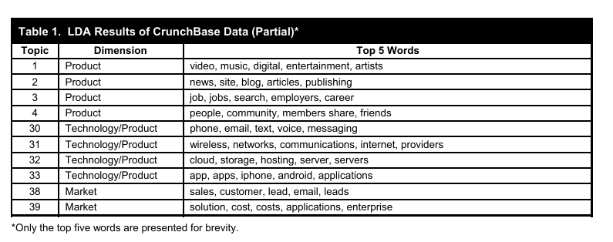

*Figure 1: LDA table showing the trends of the market and features of the products from the corpus.*

2.1.4 Findings and Conclusions

This study showcases how text mining conducted on publicly available data sources can aid in market understanding and competitor intelligence. By conducting topic modelling, the researchers were able to identify competitive and collaborative relationships between different businesses and industries. This improves the accuracy and depth of industry intelligence.

2.2.5 Implications

Projects that are focused market understanding, text mining on open-source data with topic modelling enables companies to identify any companies that are closely related to their business which can help identify potential competitors in the market along with any needs in the market that is not being met. With new opportunities found and greater insight on their competitors, companies can make use of this approach to ensure their strategic decisions are taking full advantage of the market situation.

2.2 Second Study Background

A study conducted by Kim & Jeong (2018) on using text mining to gather competitor and product intelligence. Kim & Jeong (2018) focused on online user-generated content (UGC) to conduct text mining on. Their aim is to leverage the large volume of UGC to compare two rival products, see what differences between the two products are and why a product or brand is better than its rival. This study was conducted specifically with the focus on the Korean Ramen Market and focused on the market leader and follower of that market.

2.2.1 Dataset

The researchers collected a substantial dataset of 19,386 blog posts, forum messages, customer opinions and comments collected from sites such as Naver.com, Daum.com and other similar South Korean sites that discussed two popular rival Ramen brands, Ns-ramen and Sy-ramen. This dataset captures the broad sentiment and opinions of consumers on these products, making it suitable for a comparative sentiment analysis approach.

2.2.3 Text Mining Process

They conducted sentiment analysis on the UGC. According to Kim & Jeong (2018), they were able to determine which ramen brand was the market leader and the follower through the sentiment analysis. They found out that sentiments of the UGC towards the market leader, Ns-ramen, were always more positive than the follower, Sy-ramen.

They were able to understand why this was the case when they also conducted sentiment analysis on the taste features of the products of these rival brands which are critical success factors for Ramen products. They were able to the features of the two products that have significant gaps that explained how the market leader met the needs of the market better than its rival through the UGC.

According to Kim & Jeong (2018), they were able to further investigate which taste feature of soup and ingredient led Ns-ramen to attain the market leader position due to the significant gap between Sy-ramen on those features.

2.2.4 Findings and Conclusions

The text mining and sentiment analysis approach proved effective in revealing competitive dynamics and provided a deeper understanding of consumer behaviours and preferences in the Korean ramen market. This allows brands to find out why consumers prefer their competitors and what features to focus on due to them being critical success factor to gaining market share and becoming market leaders.

This allows brands to tailor their products to better suit what the market needs and to steal market share from competitors.

2.2.5 Implications  
For projects centred on competitor and product intelligences along with customer understanding, this study exemplifies text mining can provide actionable market intelligence, especially in niche markets. By demonstrating the effectiveness of UGC analysis for brand comparison, it highlights the role of sentiment analysis in shaping strategic business decisions.

Chapter 3: Text Mining through CRISP-DM Framework

According to Saltz (2024), the Cross-Industry Standard Process for Data Mining (CRISP-DM) is “a process model with six phases that naturally describes the data science life cycle.” The six phases are 1) Business Understanding, 2) Data Understanding, 3) Data Preparation, 4) Modelling, 5) Evaluation and 6) Deployment. I will go through and discuss the text mining process using this framework.

3.1 Business Understanding

The business problem of market intelligence is that most of the external data that is used to conduct market intelligence are unstructured data which makes it hard to conduct any data mining to gain any insights about the market. This makes it hard to use the vast amount of data that is available in a useful manner and requires a lot of manual work which makes it time consuming (AlphaSense, n.d.).

The requirement of this project is that it requires a minimum of 500 rows of text records of external data that contains insights about the market. We will need to pick external data that is able to cover the situation of the general situation of the market. Therefore, I will choose to conduct text mining on British Broadcasting Corporation (BBC) news articles as it covers global events and has a section dedicated to business news.

The data mining goal is to identify prominent topics in the news articles to understand any trends in the market and analyse the sentiment in the articles to gauge the public’s opinions on those topics.

3.2 Data Understanding

This is the second stage of the CRISP-DM Framework and will cover the data collection, exploring the data and verifying data quality.

3.2.1 Data Collection

The dataset is a compilation of BBC articles from Kaggle.com. The dataset consists of two columns where a column consist of the articles and another column is a label where it classifies what type of article it is. It is available for download in a .csv file.

The file was downloaded from the website and exported to an Excel sheet for data exploration.

The dataset may contain few spelling mistakes that may have arisen from the initial data collection process from the BBC website such as during the web-scrapping process. This will be handled during data preparation stage where text data pre-processing will occur.

3.2.2 Exploring the Data

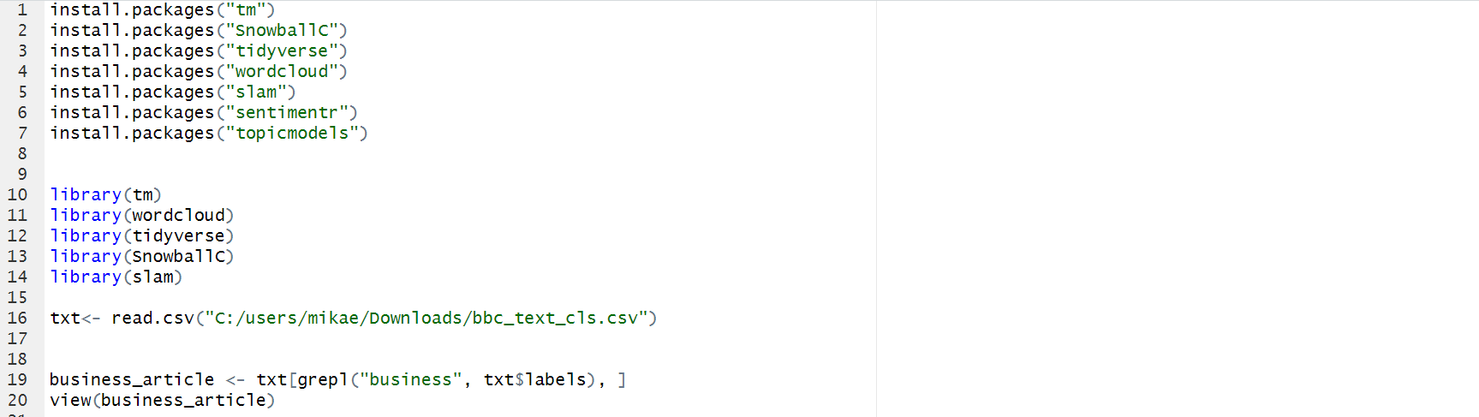

*Figure 2: Code used to inspect the dataset*

I used R to view the text data by loading the dataset into R with the code shown in Figure 2.

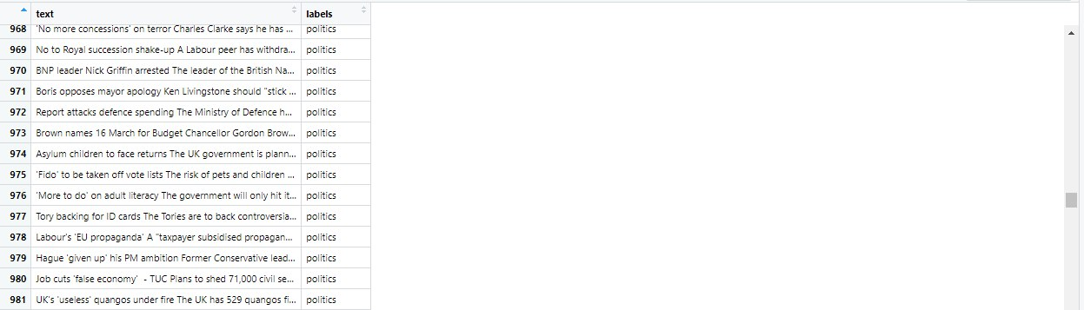

*Figure 3: The columns of the dataset*

The dataset contains 2225 rows of text data, and each data has two columns. Referring to Figure 2, one of the columns is labelled ‘text’ which contains the text data, and the other column is ‘labels’ which shows the category of the text. There are five categories of text which are ‘business’, ‘entertainment’, ‘politics’, ‘sports’, and ‘tech’. Each row of text data represents a BBC news article.

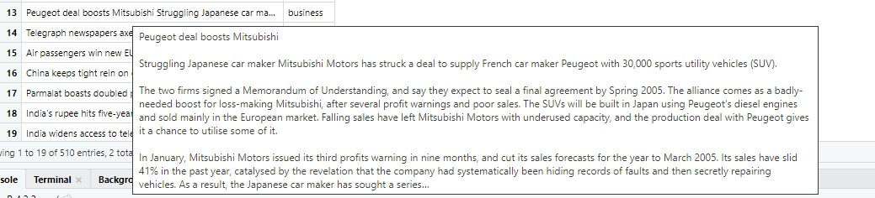

*Figure 4: Example of text data*

The BBC articles in the dataset are dated from 2005 and will therefore cover events from that period. This allows us to gauge how well text mining can gain any market intelligence as we are able to check how well it captures the situation and trends of that era due to hindsight.

There are special terms and vocabulary that are related to business such as ‘bankruptcy’, ‘deficit’, ‘budget’ and other words commonly used in the business setting.

As the BBC also cover current events around the world, there may contain other special terms and vocabulary that are not related to other categories. However, we will not be focusing on those types of terms and vocabulary. This is because we will not be focusing on those categories. We will only focus on text data labelled as ‘business’.

3.2.3 Verifying data quality



*Figure 5: Examining the dataset in Excel.*

When examining the dataset in Excel, some of the text data contains non-standard formats such as the irregular characters in the text.

However, when examining the data in R, the irregularities were gone from the text data.

3.3 Data Preparation

For this project, we only want to conduct market understanding of market intelligence. Therefore, we will only focus on articles in the business category. However, if a company that specializes or operates in the tech industry, it will have to focus on articles in both the tech and business categories to have a proper outlook on the market. Data preparation of this step in text mining will be very important as it controls the type of external data that text mining will be conducted on. This step is unique for every scenario and should be done with utmost care.

Step 1: As seen in Figure 2, we will need to load the necessary packages first and import the dataset for text pre-processing.



Figure 6:

Step 2: We will only focus on articles in the business category and disregard the rest of the articles in the dataset.

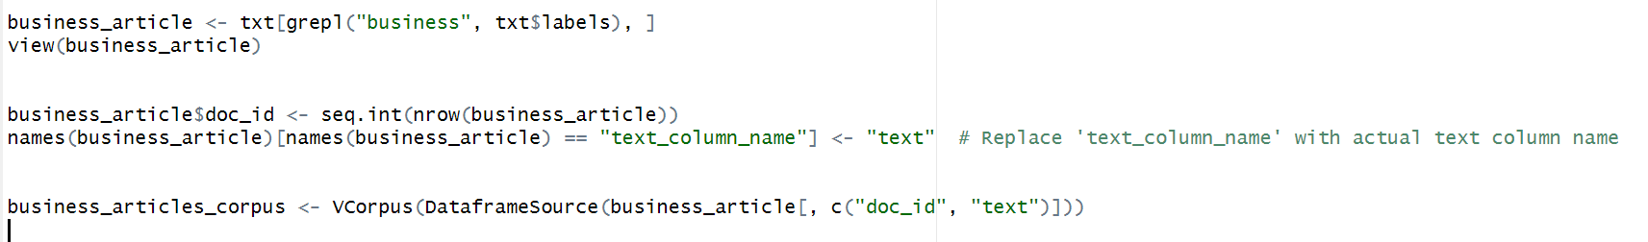

*Figure 7: Extracting text data categorised as ‘business’ to convert the data frame txt into a Corpus*

Step 3: We will conduct case normalisation to lowercase for consistency.



*Figure 8: Code for case normalisation*

Step 4: Removing punctuations.



*Figure 9: Code for removing punctuations.*

Step 5: Removing numbers



*Figure 10: Code for removing numbers.*

Step 6: Removing non-English words with spaces.



*Figure 11: Code for removing non-English words with spaces*

Step 7: Create a list of stop words and store in a .data file.

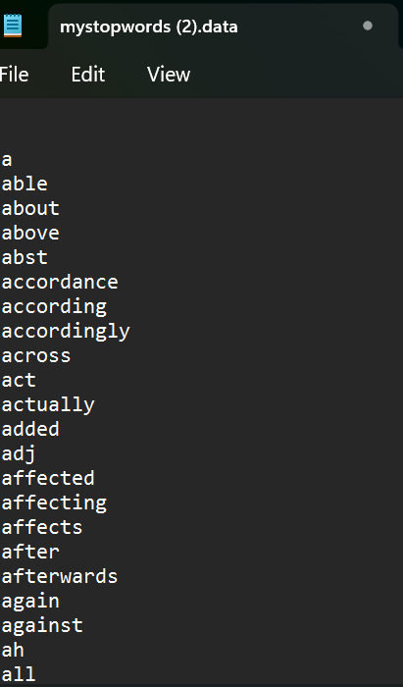

*Figure 12: Example of common stop words in the English language.*

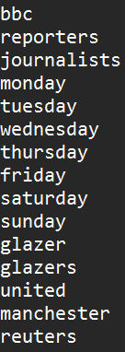

*Figure 13: Customized stop words for topic modelling.*

Step 8: Import and remove customised stop words.

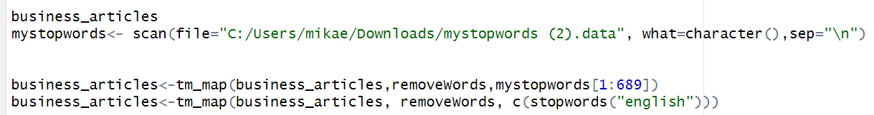

*Figure 14: Code for importing and removing customised stop words.*

Step 9: Removing white space and generating the Document-Term Matrix



*Figure 15: Code for removing white space and generating the Document-Term Matrix.*

Step 10: Check the terms in the Document-Term Matrix.

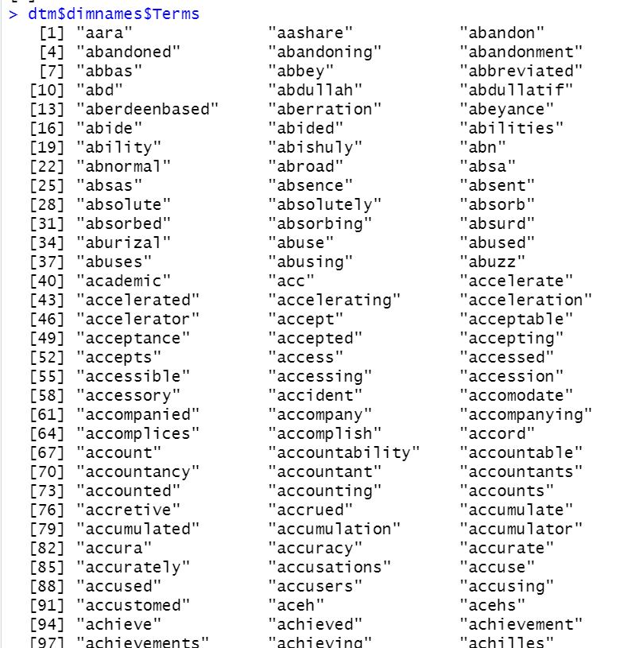

*Figure 16: Check the terms in the Document-Term Matrix*

Step 11: Check the dimension of the Document-Term Matrix

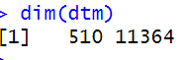

*Figure 17: Code for checking the dimension of the Document-Term Matrix.*

I have skipped the stemming step as it has resulted in difficulties in interpreting the Topics generated during the Modelling stage with the words in their root forms.

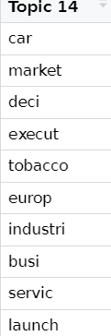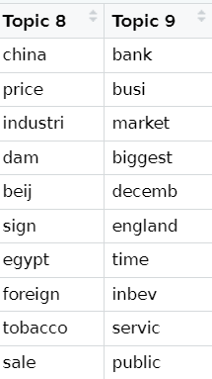

*Figure 18: Example of Topic Modelling difficulties with stemming*

3.4 Modelling

Our first model will be Topic Modelling where we will use LDA to identify key topics from each article. We will select an optimal number of topics based on interpretability and extract the most representative terms for each topic to summarize their themes.

Our second model will be a Sentiment Analysis model where it will extract sentiment scores for each article and analyse the distribution of sentiment by category to understand tone variations across topics.

3.4.1 Building the Topic Modelling model

Step 1: Check the basic information of dtm. 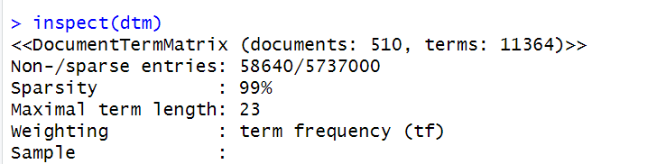

*Figure 19: Output of inspect(dtm)*

Step 2: Get the statistical summary of TF-IDF values using summary(dtm_tfidf$v).

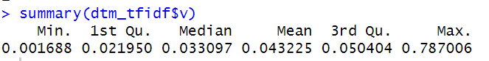

*Figure 20: Median of TF-IDF values is 0.032970*

Step 5: Remove terms with a TF-IDF values below 0.05 from the Document-Term Matrix, dtm.



Figure 21:

Step 6: Check the basic information of the reduced Document-Term Matrix, dtm_reduced.

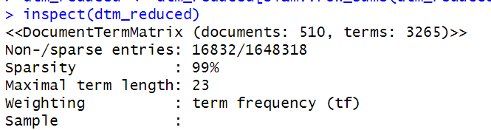

*Figure 22: Output of inspect(dtm_reduced)*

Step 7: Load the package and build LDA topic models with k topics using (1) VEM and (2) Gibbs sampling methods.

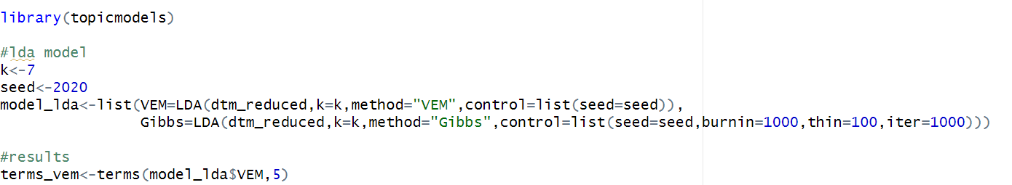

Figure 23:

Step 8: Build LDA topic models with k topics using (1) VEM and (2) Gibbs sampling methods

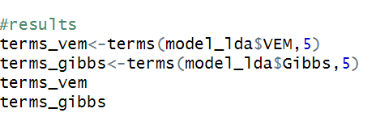

*Figure 24: The topic-document relationship*

|  |  |
| --- | --- |
| Topic | VEM |
| Stock exchange and financial markets | club, deal, fiat, boerse, exchange |
| Corporate financial performance | companies, shares, share, profit, companies |
| Bankruptcies in Russian energy industry | yukos, company, bankruptcy, gazprom, mci |
| Economic growth and interest rates | Growth, figures, rate, dollar, interest |
| Oil and energy markets | Crude, growth, president, months, company |
| Aviation industry | Company, airline, deal, companies, shares |
| Political Influence | People, president, work, aid, companies |

|  |  |
| --- | --- |
| Topic | Gibbs |
| Economic Growth and Financial Indicators | Growth, rate, months, figures, interest |
| Corporate Investment and Profitability | Company,investment, Europe, profit, news |
| Labor and Workforce Costs | People, worlds, cost, work, good |
| Russian Energy Sector | Company, yukos, bankruptcy, giant, gazprom |
| Stock Markets and Shareholders | Shares, deal, exchange, share, shareholders |
| International trade and economic policy | Dollar, president, countrys, south, lost |
| Aviation Industry and Corporate Announcements | Companies, statement, move, airline, news |

Step 9: Generate the topic distribution for each document. This will be used during the evaluation stage later.

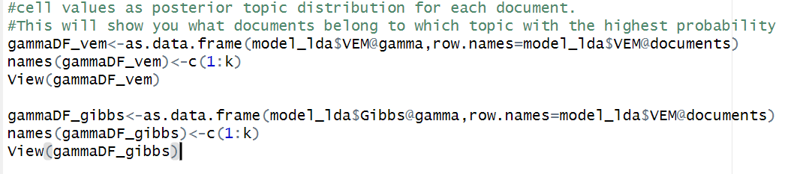

*Figure 25: Code to generate the topic distribution for both VEM and Gibbs Sampling Method*

Attempts with other values of k

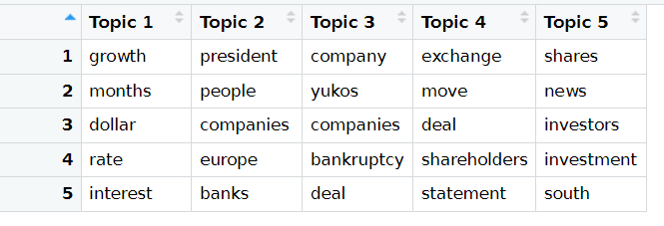

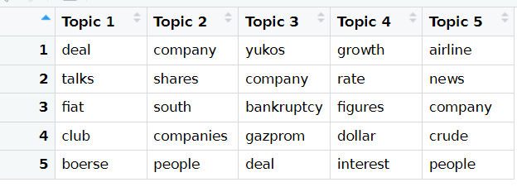

*Figure 26: Output of k=5 for Gibbs Sampling Method (top) and VEM (bottom).*

For k = 5, the topic of Russian gas industry is more detailed, but the other topics suffer like in Topic 2 for both method where there is no coherent theme.

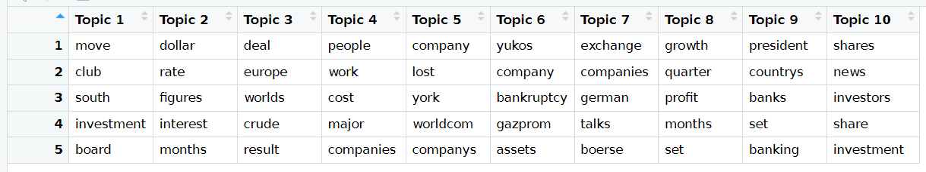

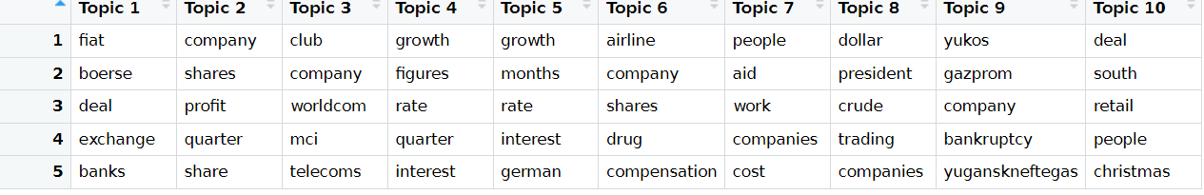

*Figure 27: Output of k=10 for Gibbs Sampling Method (top) and VEM (bottom).*

The same problem happens where only a few topic have coherent themes.

3.4.2 Building the Sentiment Analysis Model

Now, we will build the Sentiment Analysis Model that will extract sentiment scores for each article.

Step 1: As seen in Figure 2, we have already installed the sentimentr package and will load it now.

Step 2: Get sentences from the text column and store in mytext.

Step 3: Get the sentiment scores by sentences

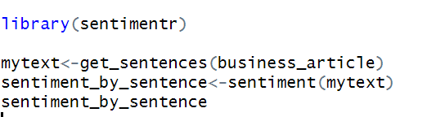

*Figure 26: Code for Steps 1 to 3.*

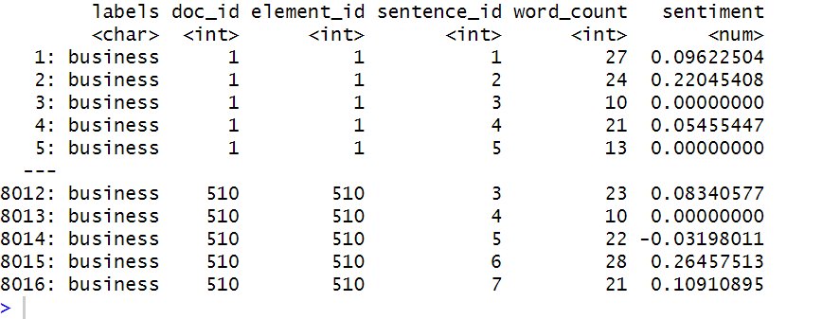

*Figure 27: Sentiment scores by Sentences*

Step 5: Conduct sentiment analysis by article

Step 6: Combine sentiment score and the original business article dataset.

Step 7: Convert the predicted sentiment score to a categorical variable.

Step 8: View the new dataset with tweets and predicted polarity.

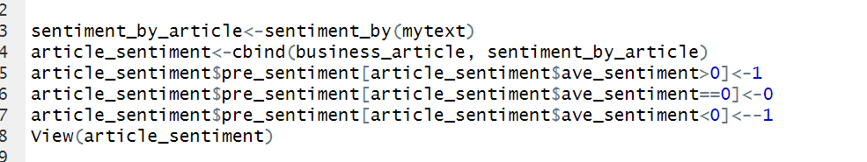

*Figure 28: Code for Steps 5 to 7*

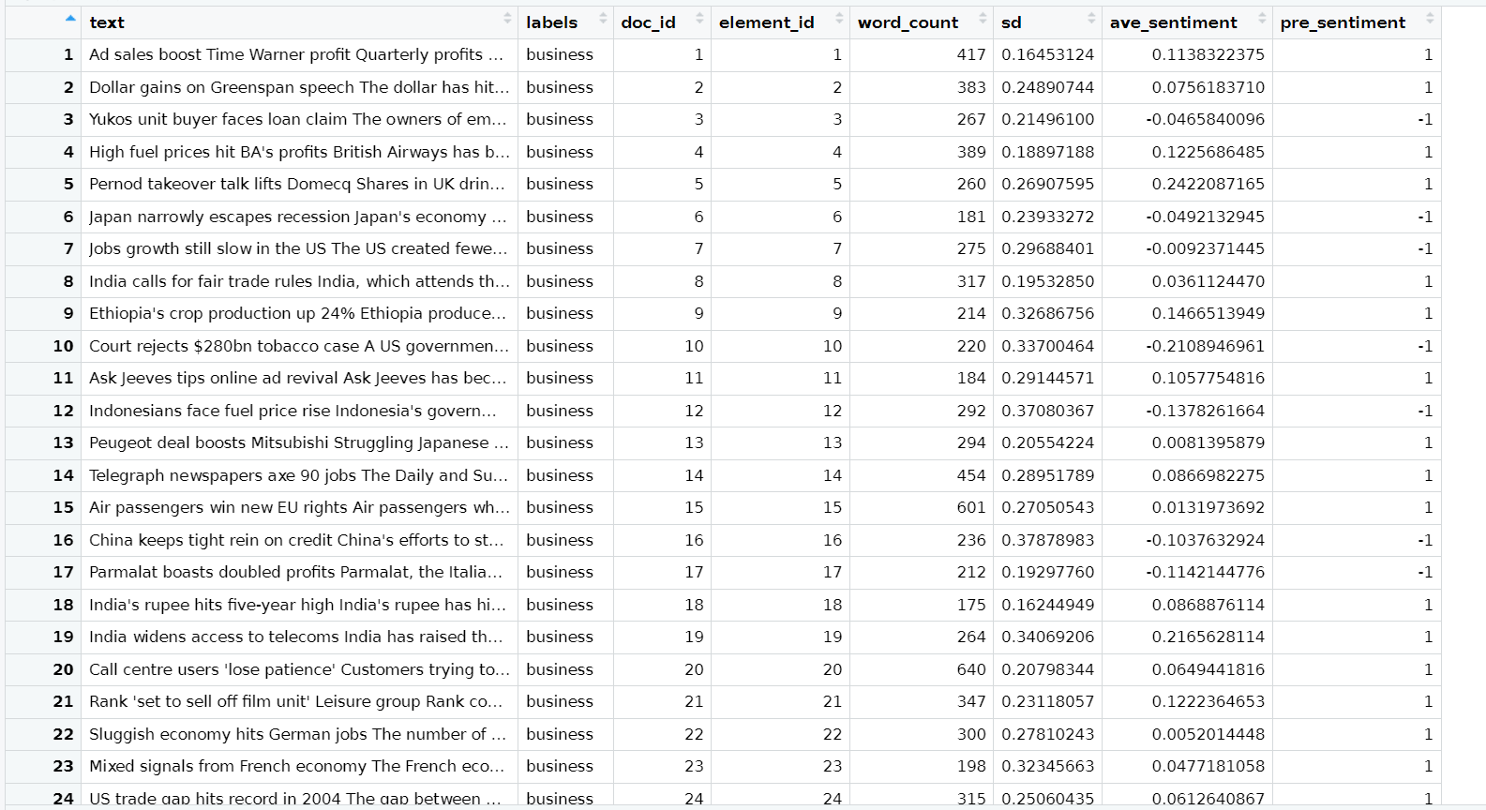 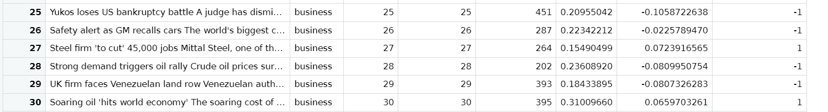

*Figure 29: First 30 rows of Sentiment Analysis.*

3.5 Evaluation

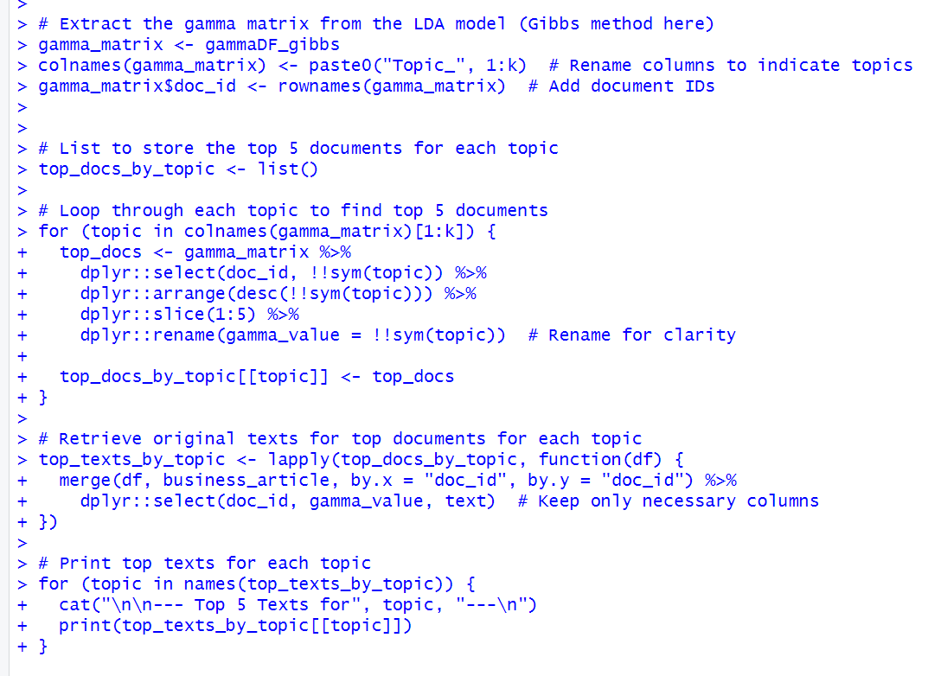

*Figure 30: Code for getting top 5 texts of each topic discovered under Gibbs Sampling Method.*

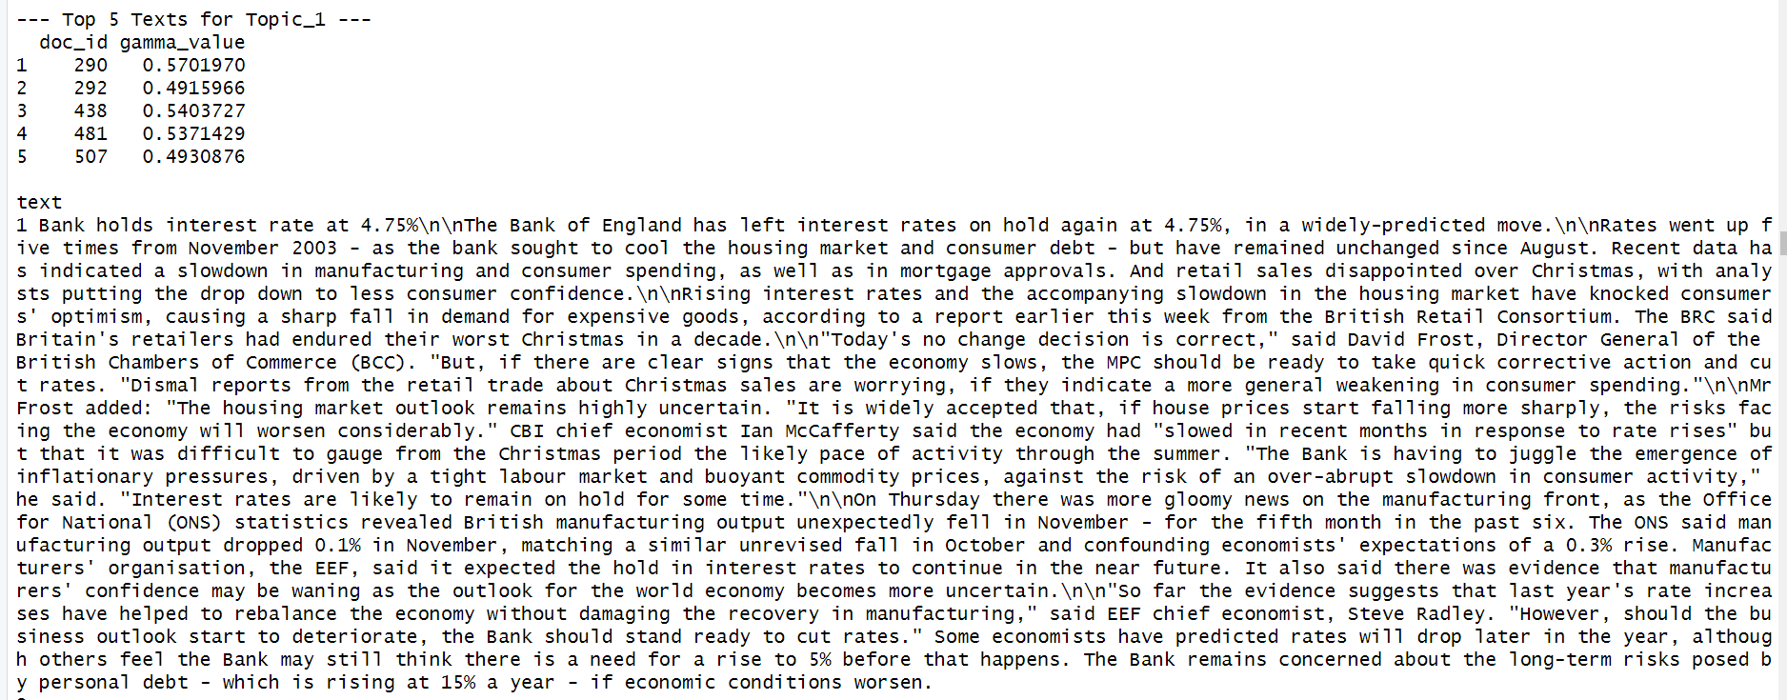 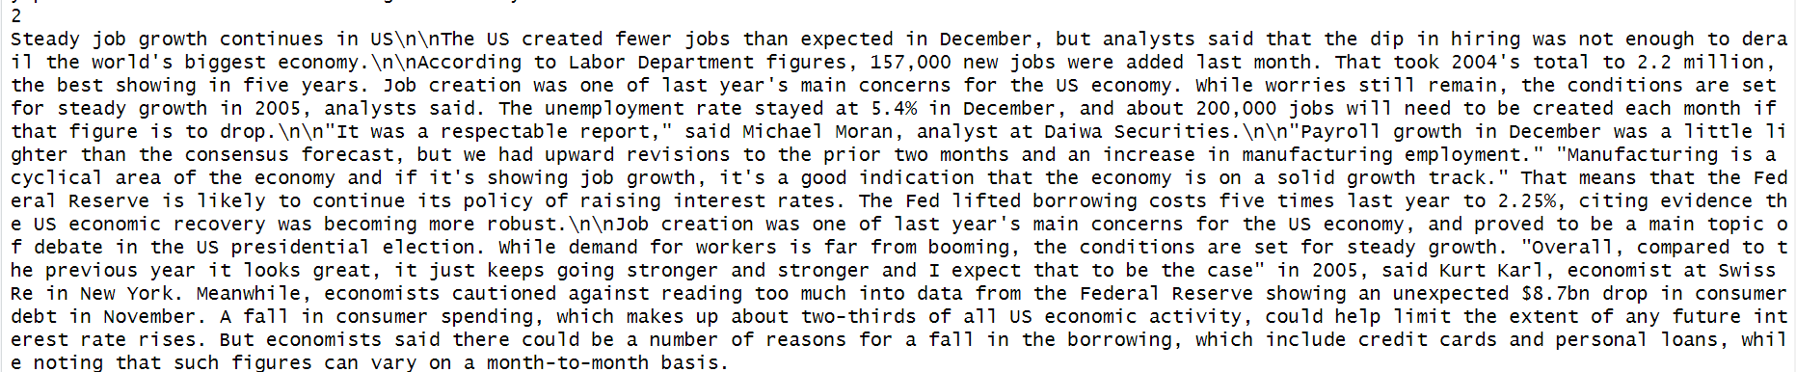 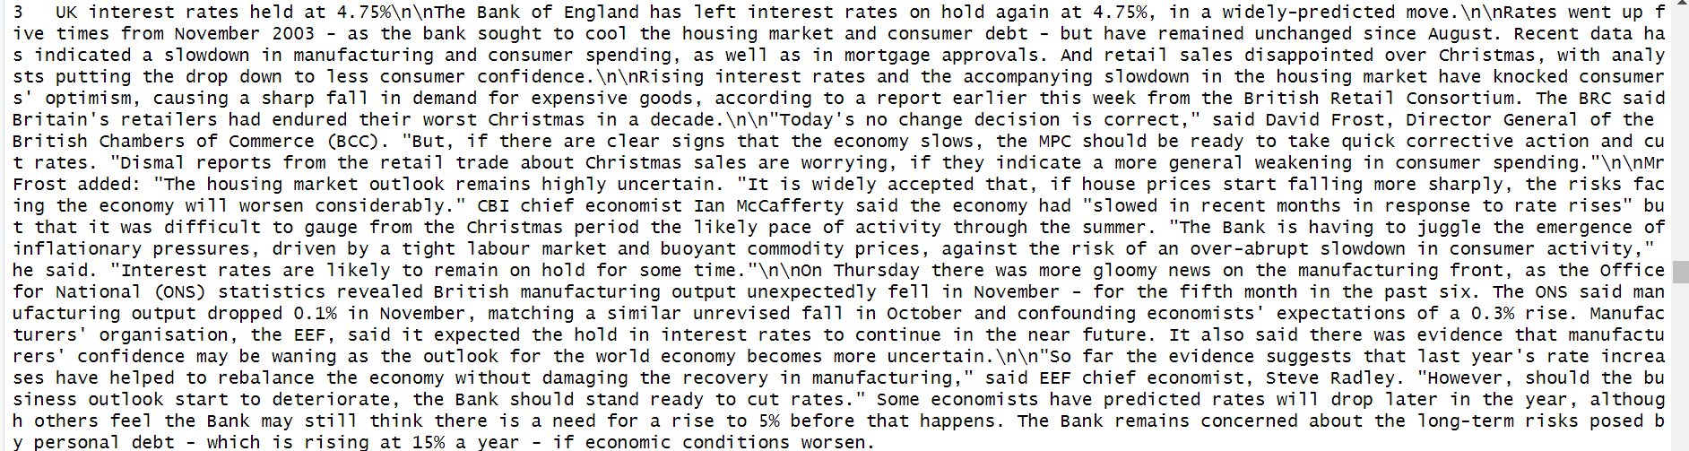 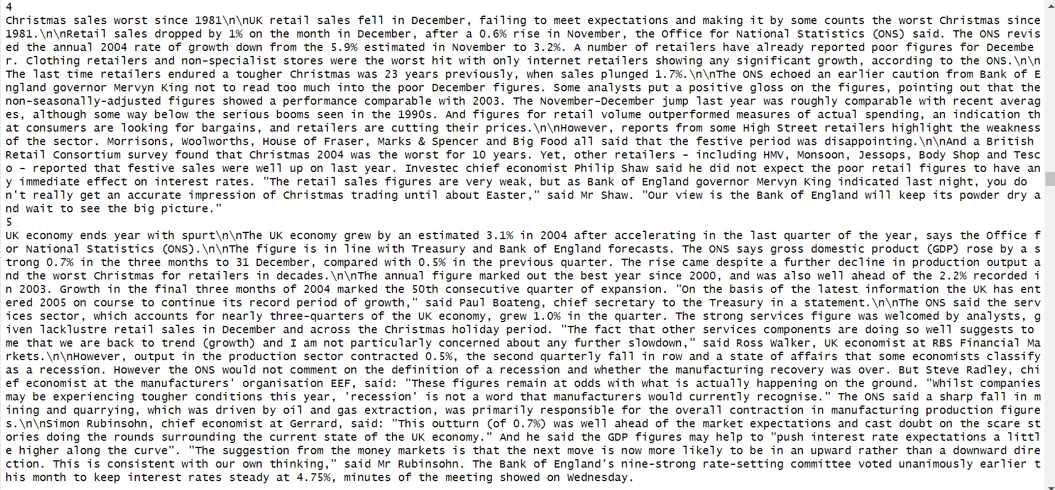

*Figure 31: Top 5 texts of Economic Growth and Financial Indicators*

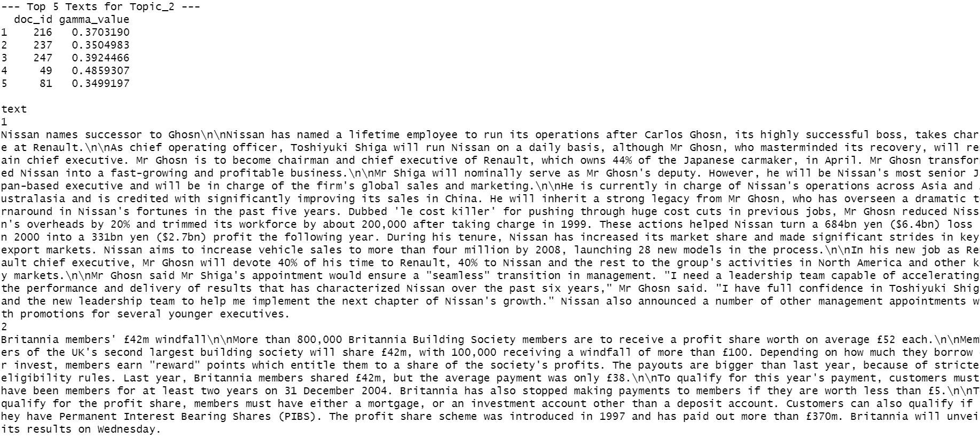

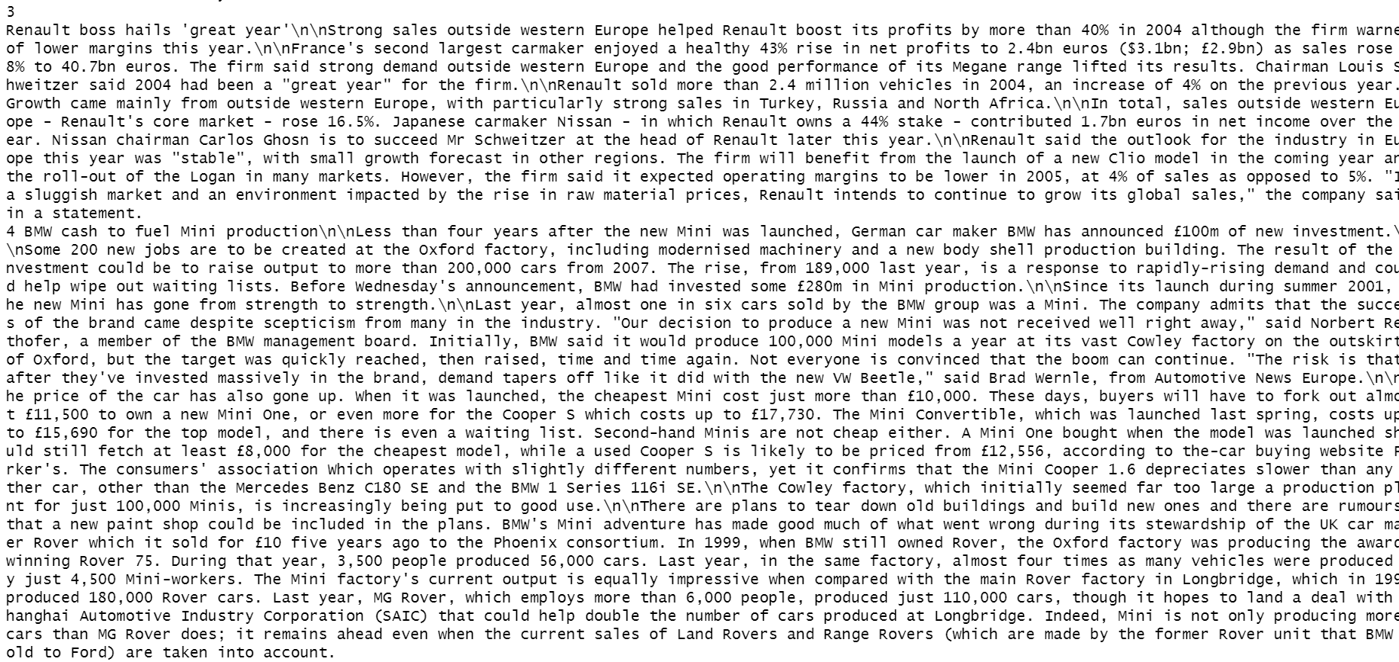

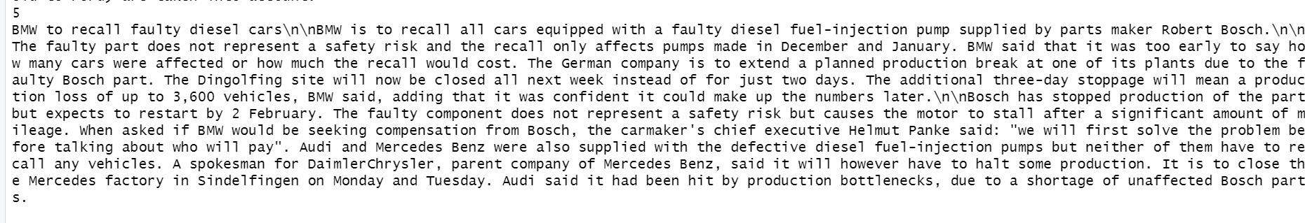

*Figure 32: Top 5 texts of Corporate Investment and Profitability*

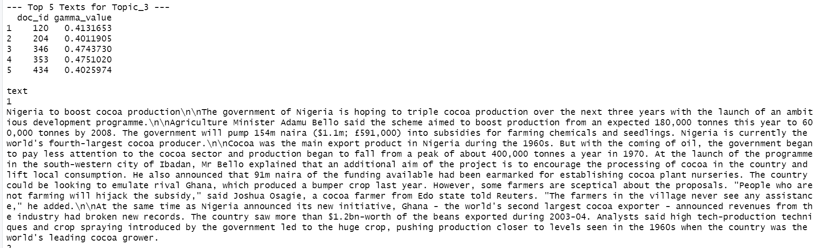

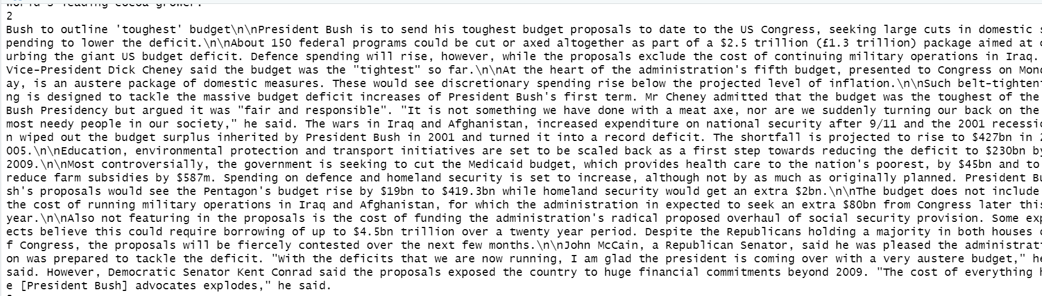

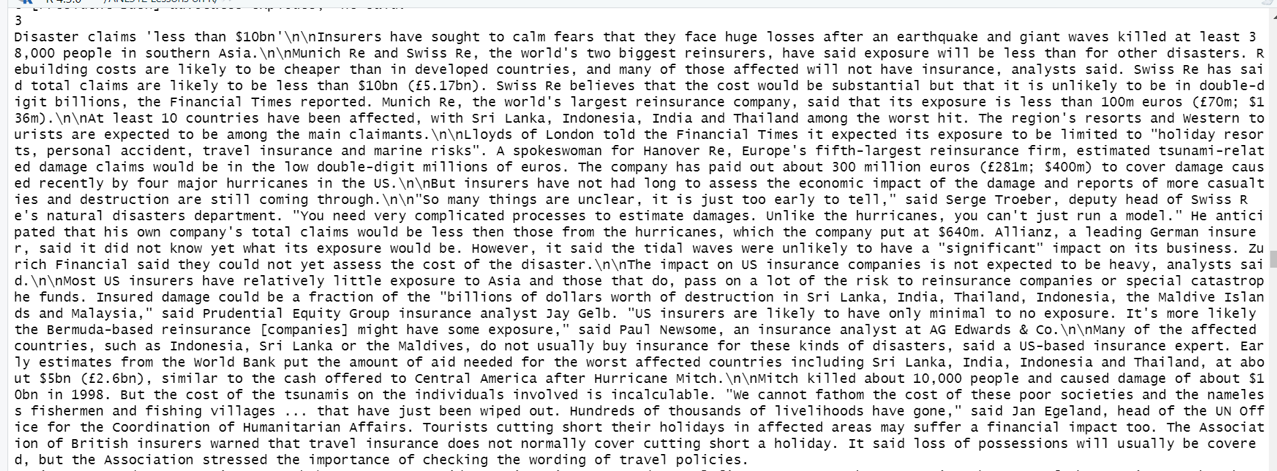

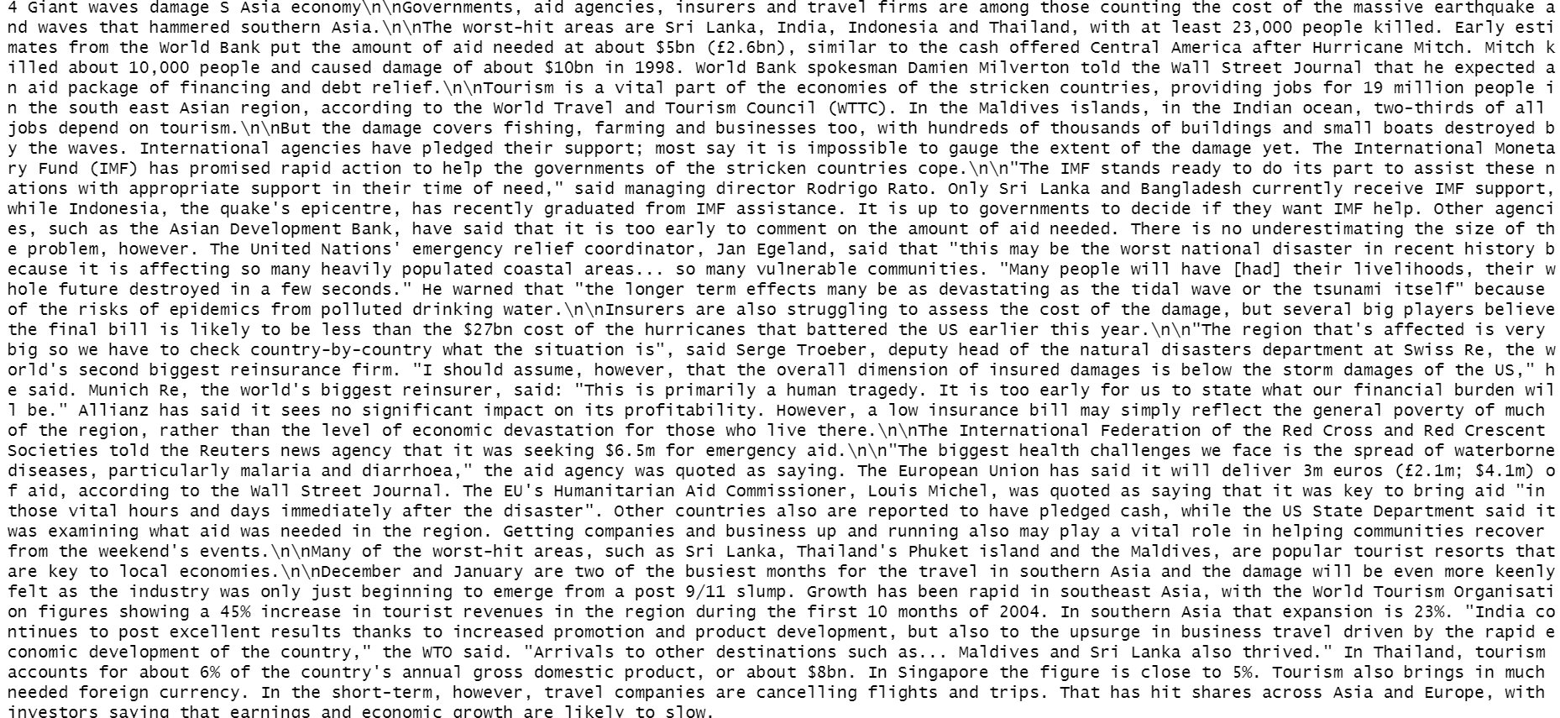

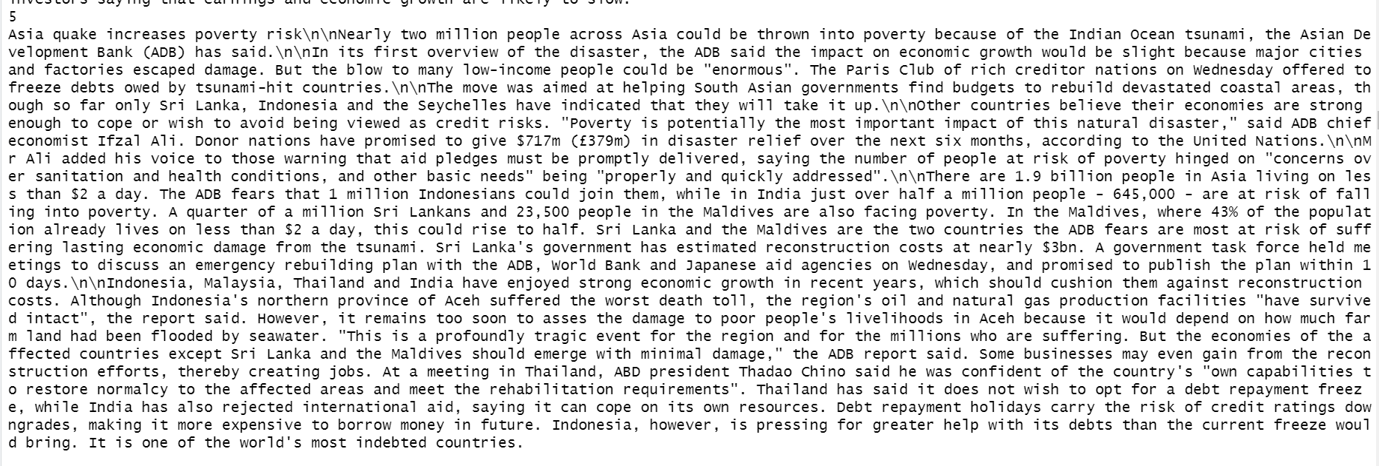

*Figure 33: Top 5 texts of Labour and Workforce Costs*

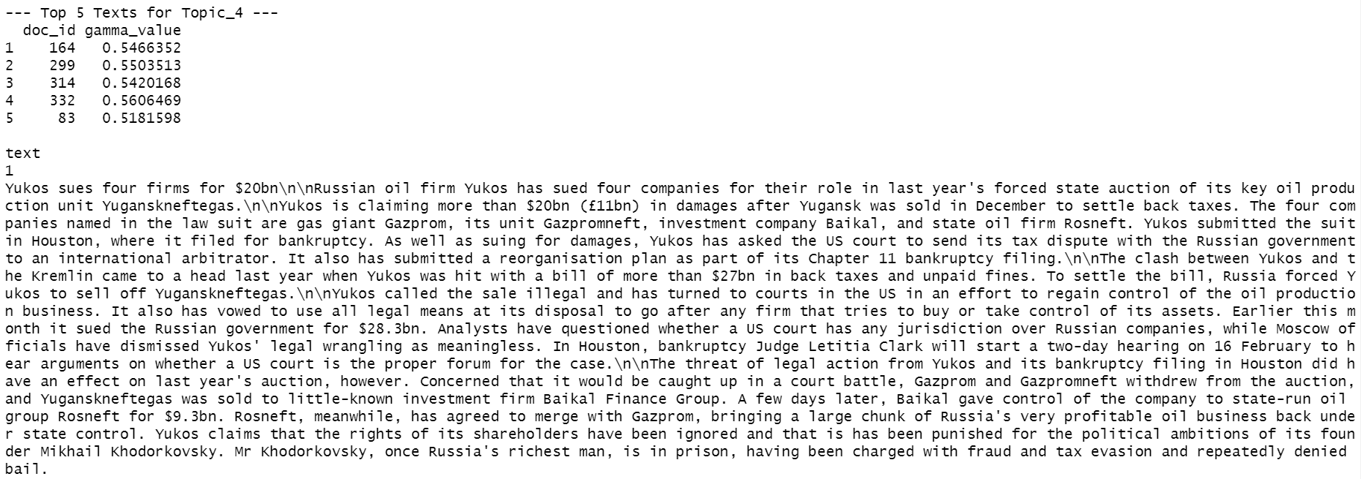

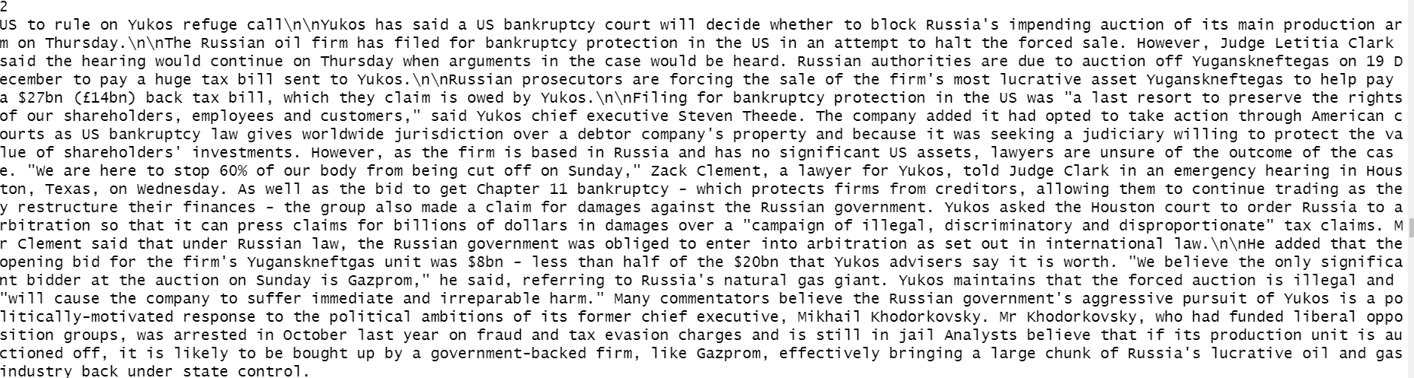 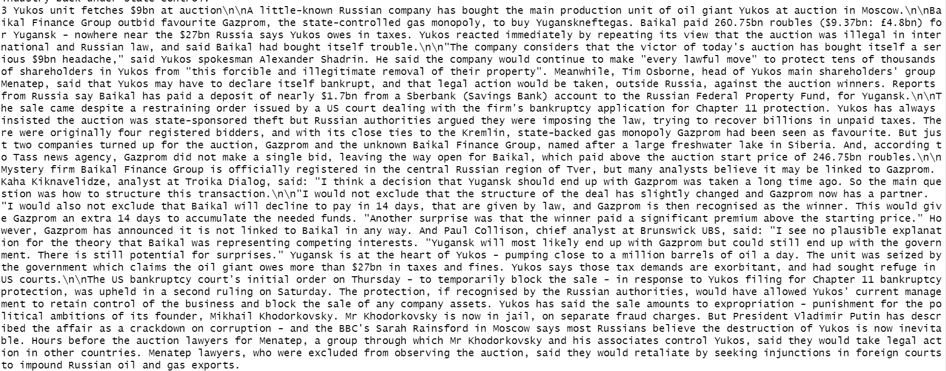 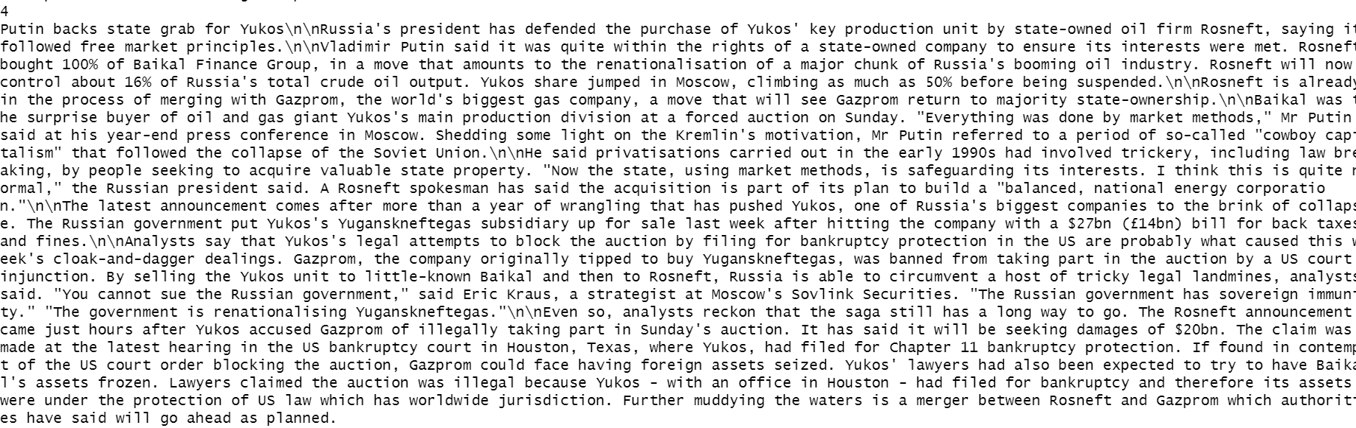 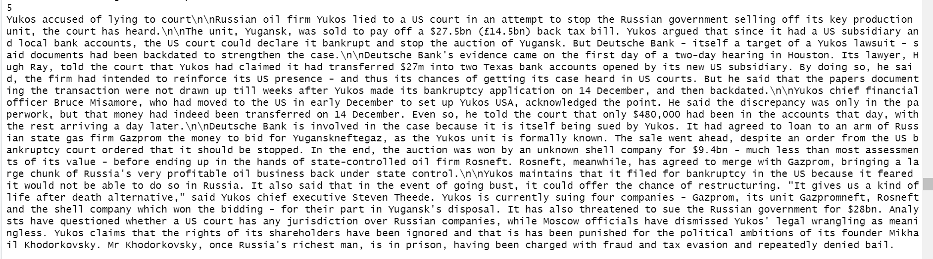

*Figure 34: Top 5 texts of Russian Energy Sector*

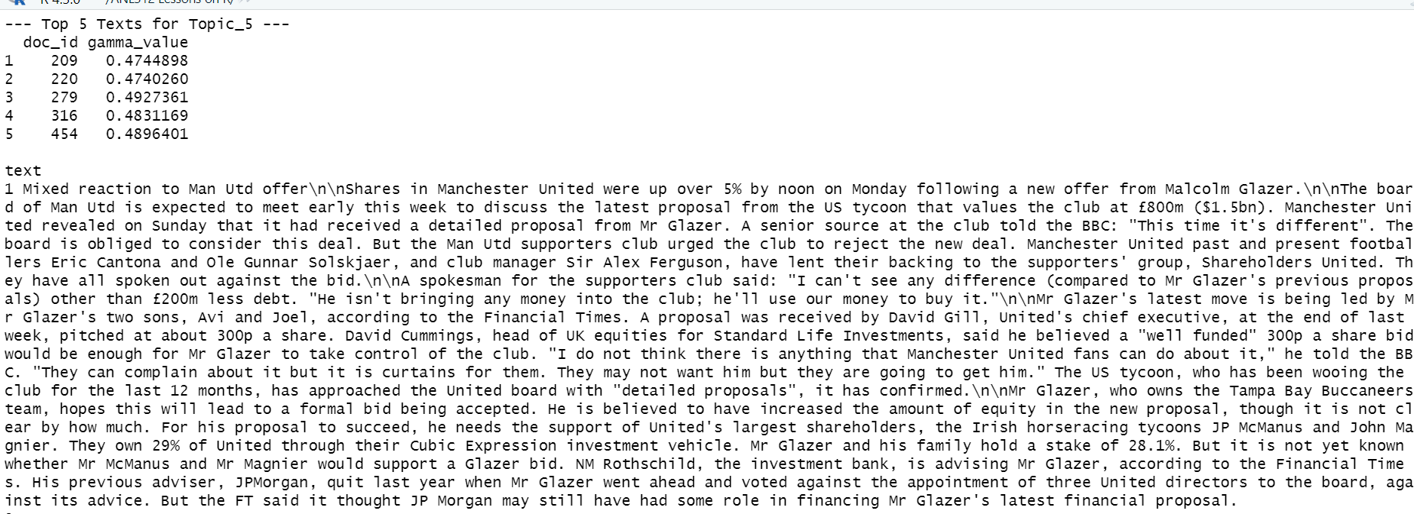 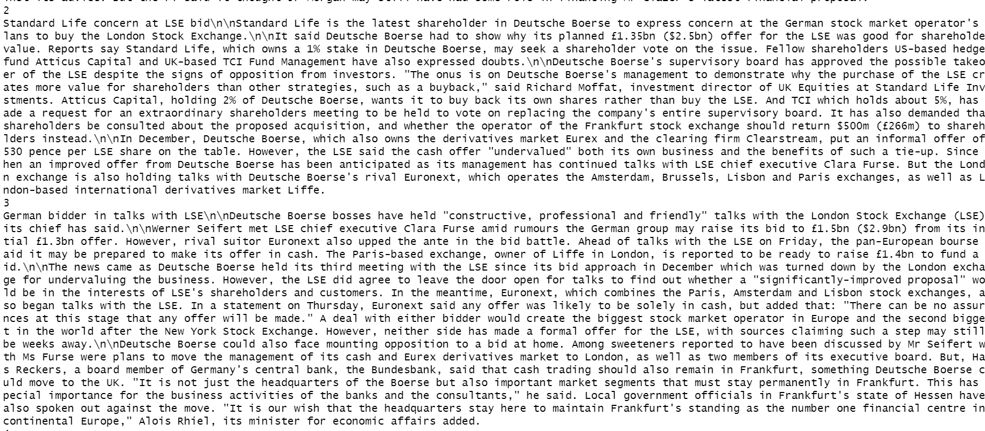

*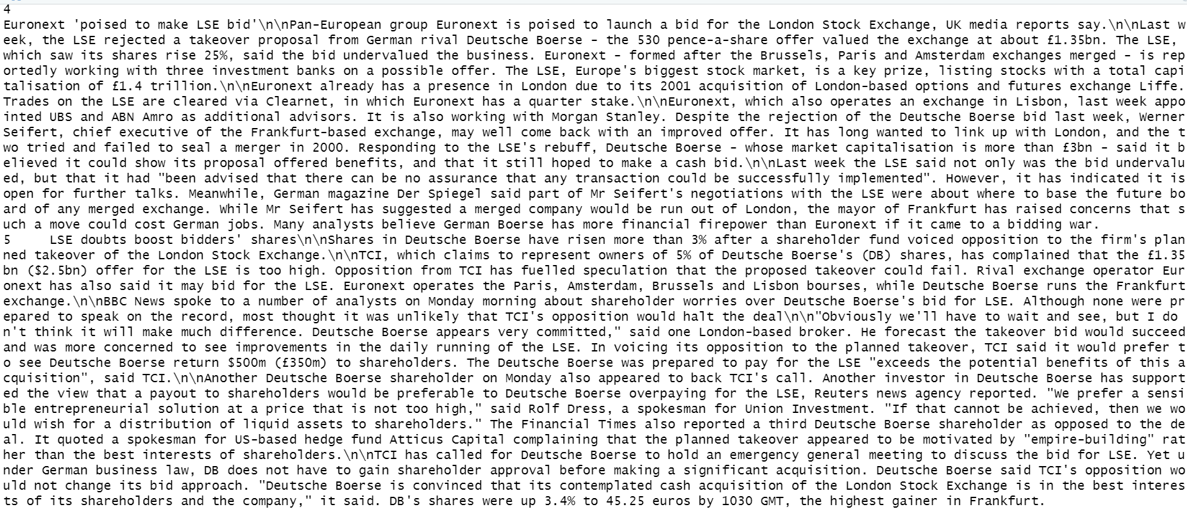Figure 35: Top 5 texts of Stock Markets and Shareholders*

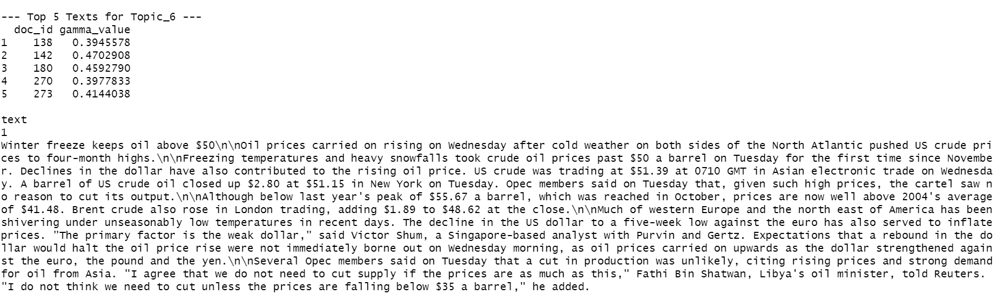 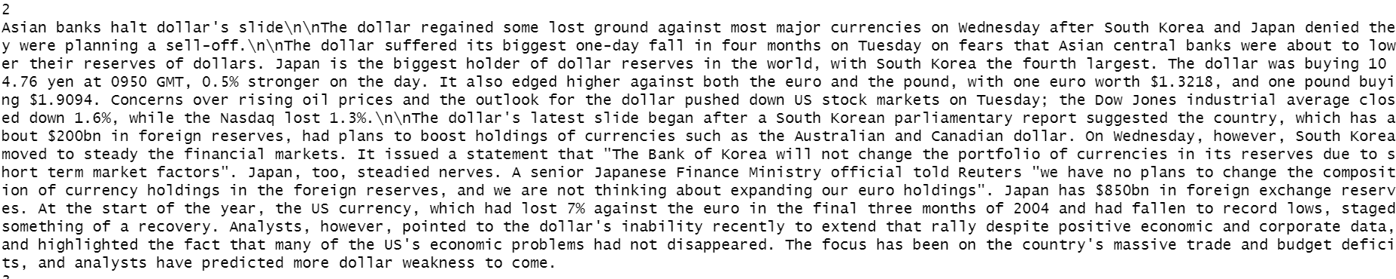 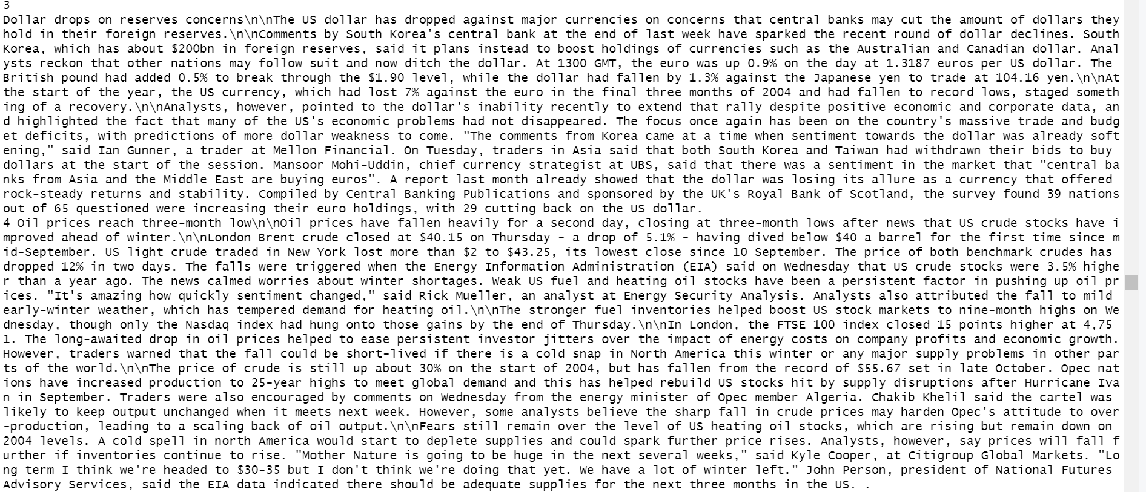 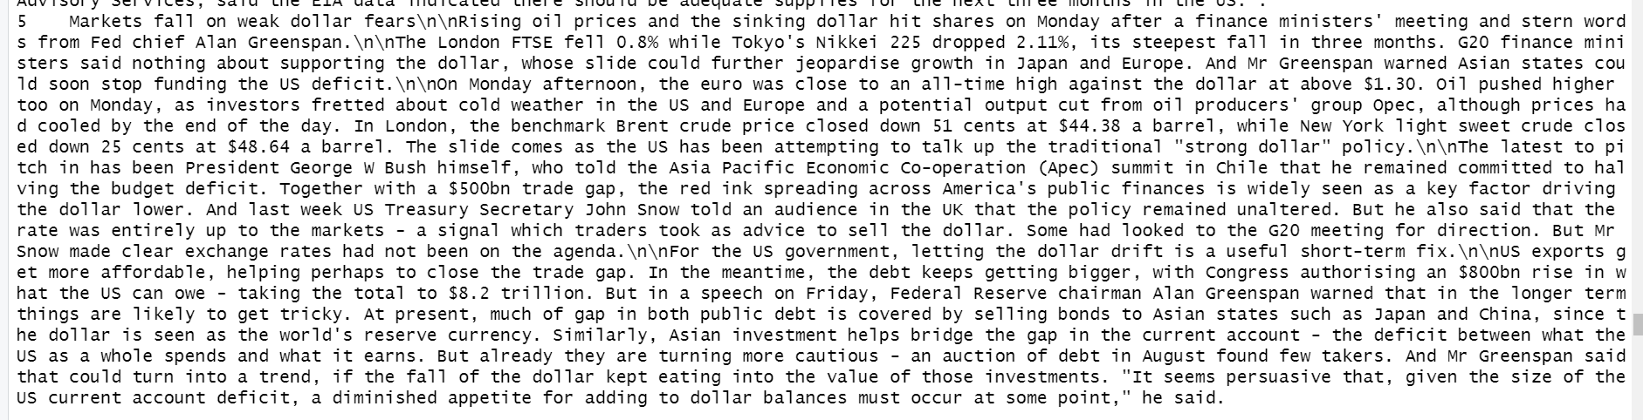

*Figure 36: Top 5 texts of International Trade and Economic Policy*

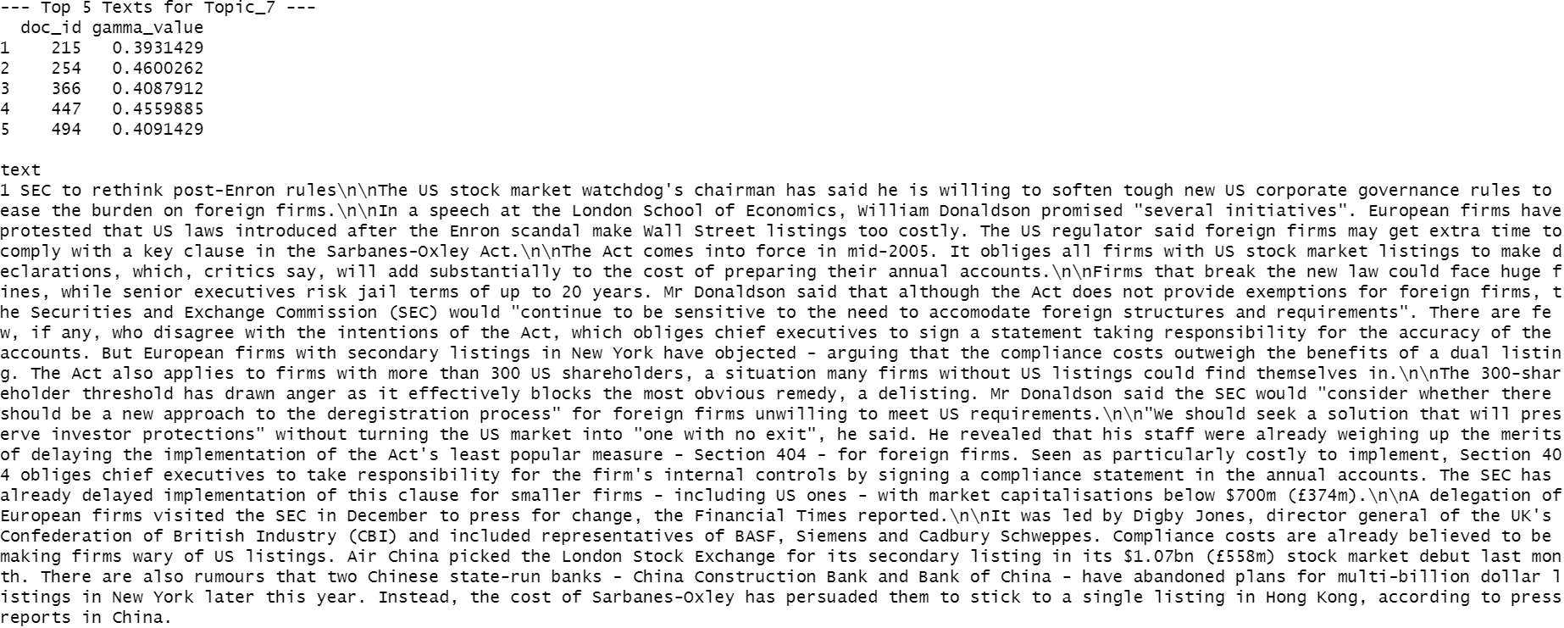 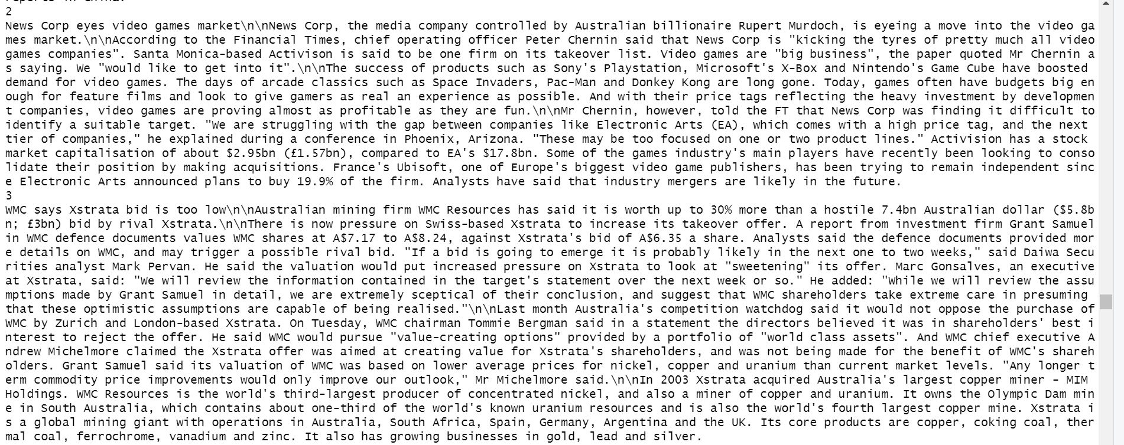

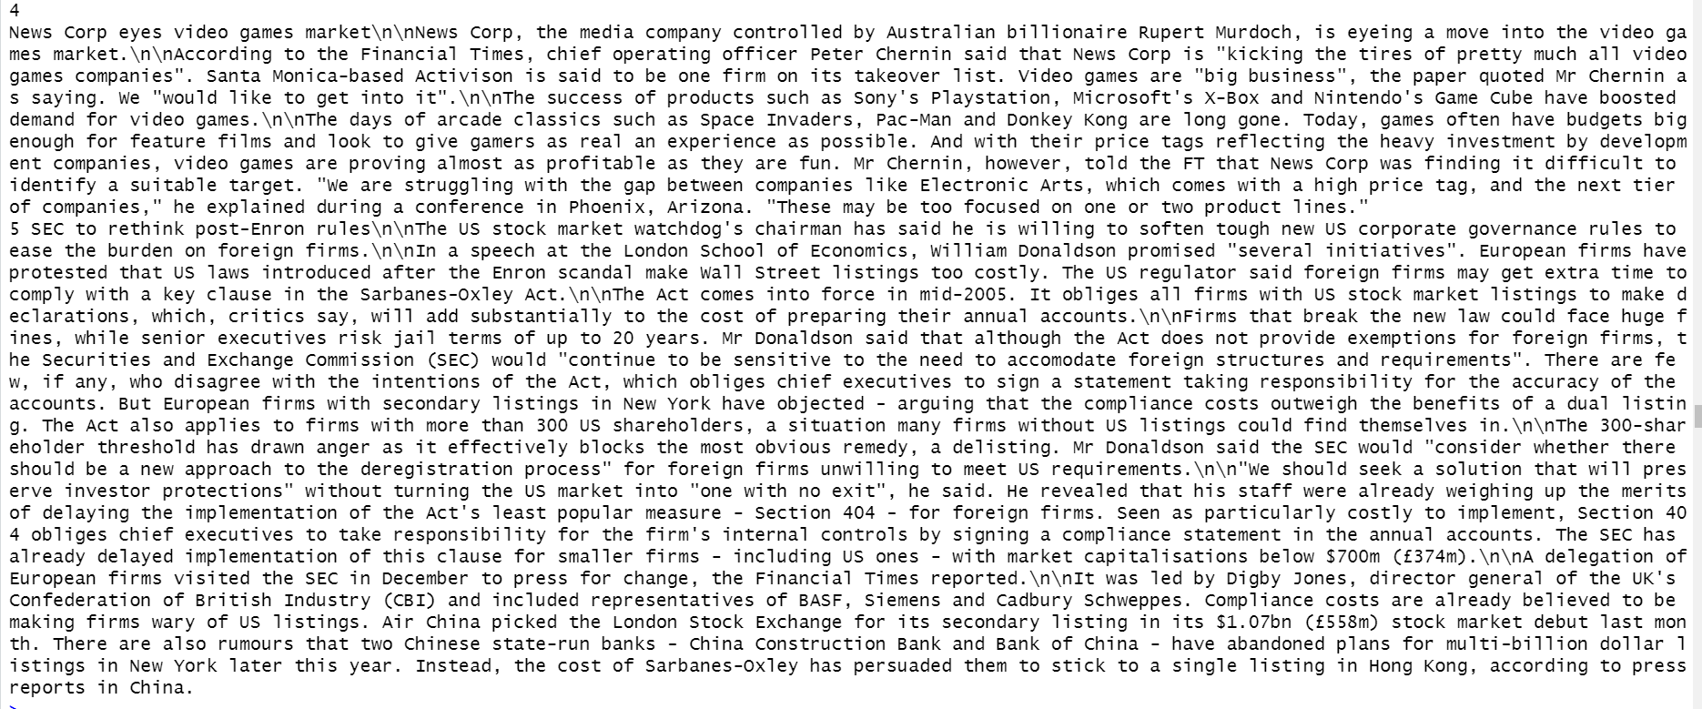*Figure 37: Top 5 texts of Aviation Industry and Corporate Announcements*

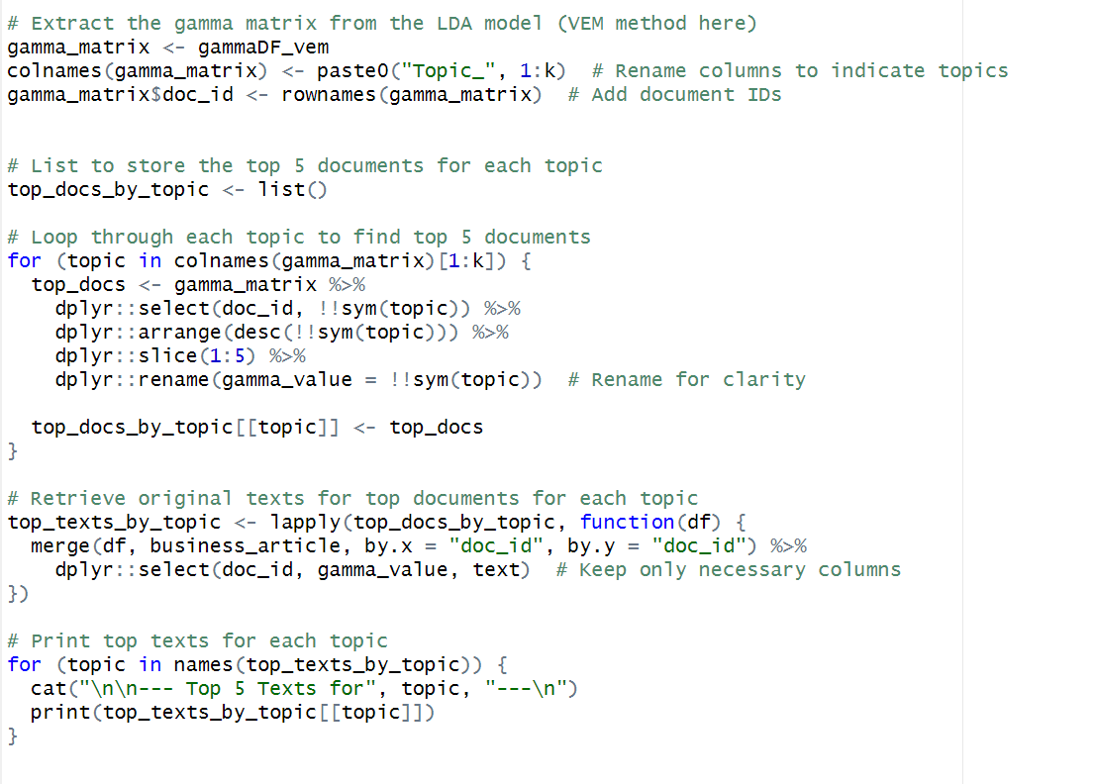

*Figure 38: Code for getting top 5 texts of each topic discovered under VEM Sampling Method.*

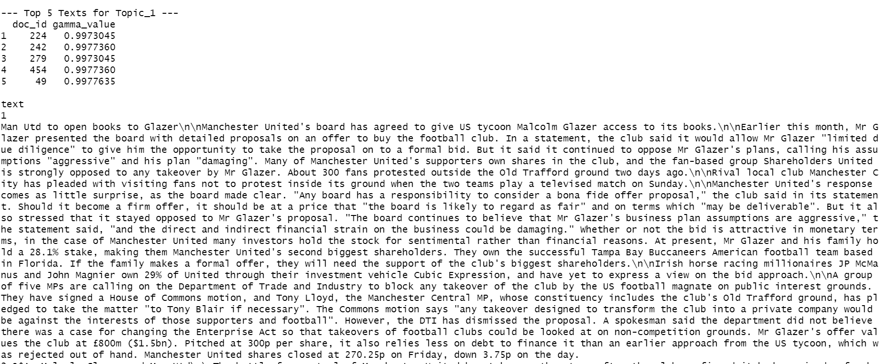 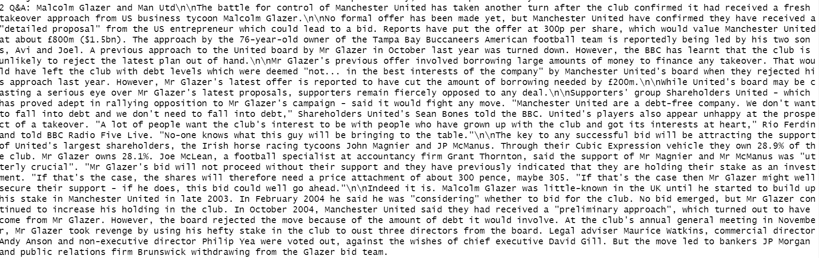 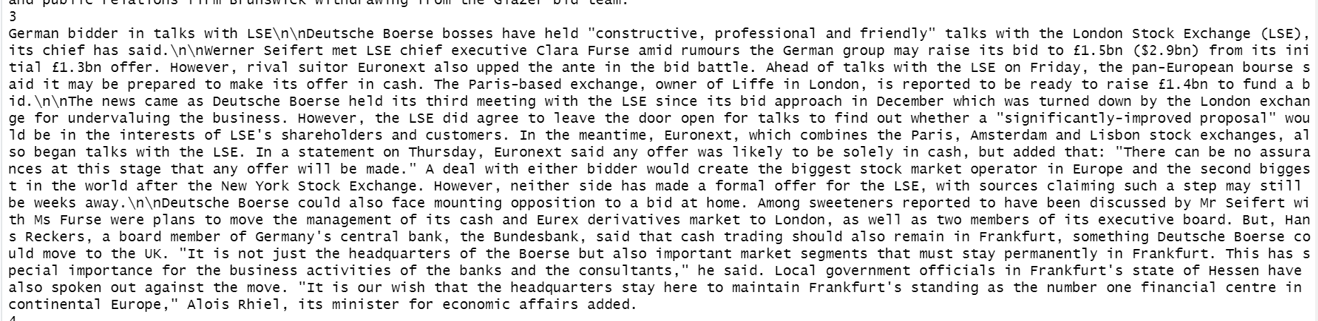 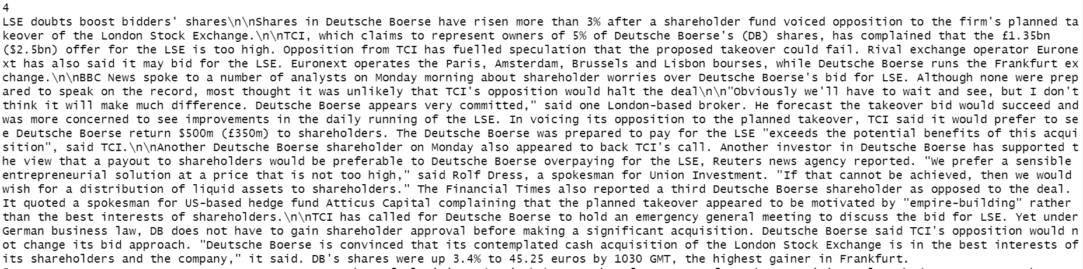 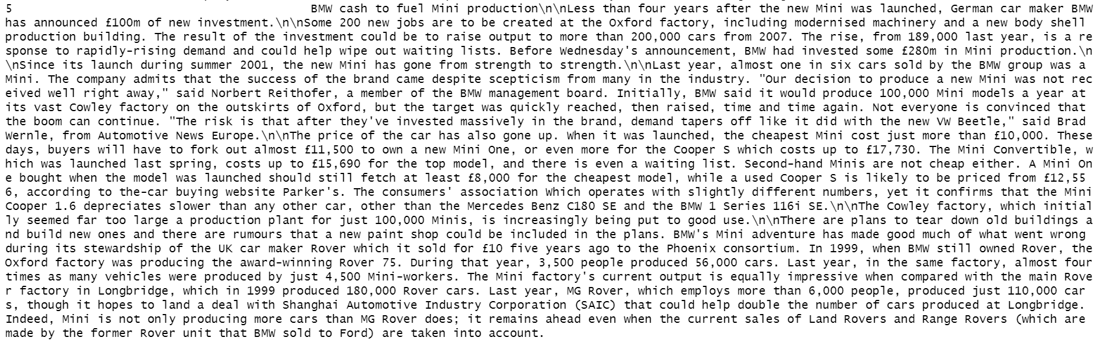

*Figure 39: Top 5 text of Stock Exchange and Financial Markets*

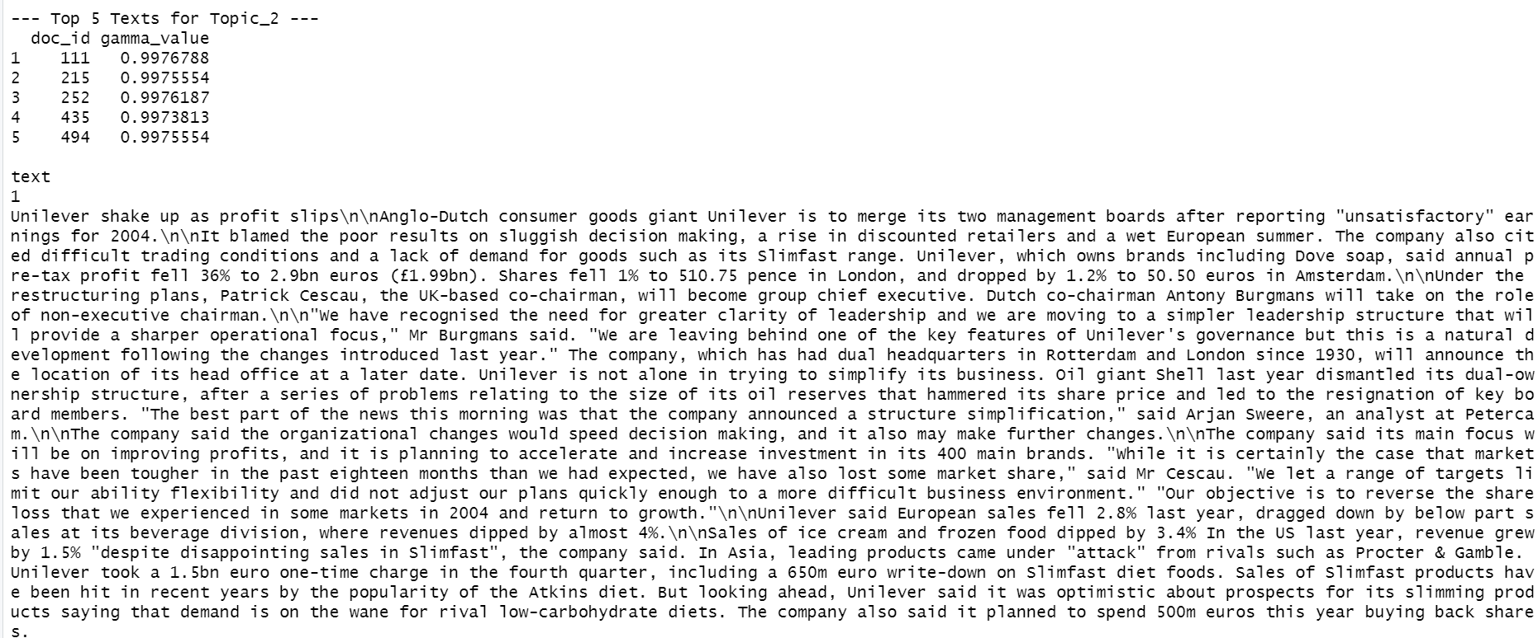 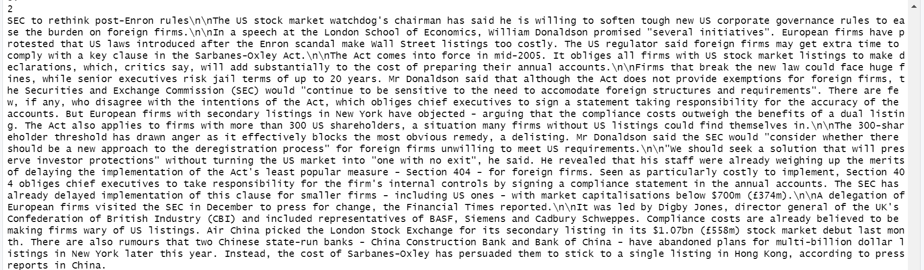 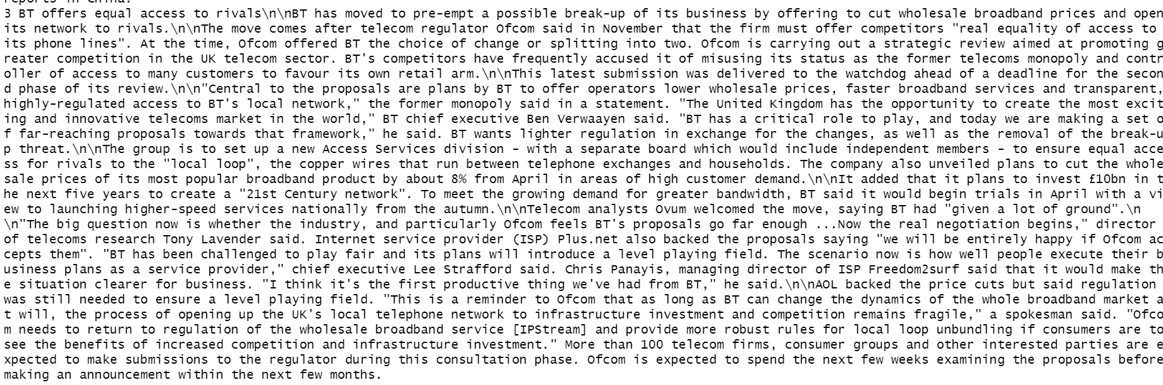 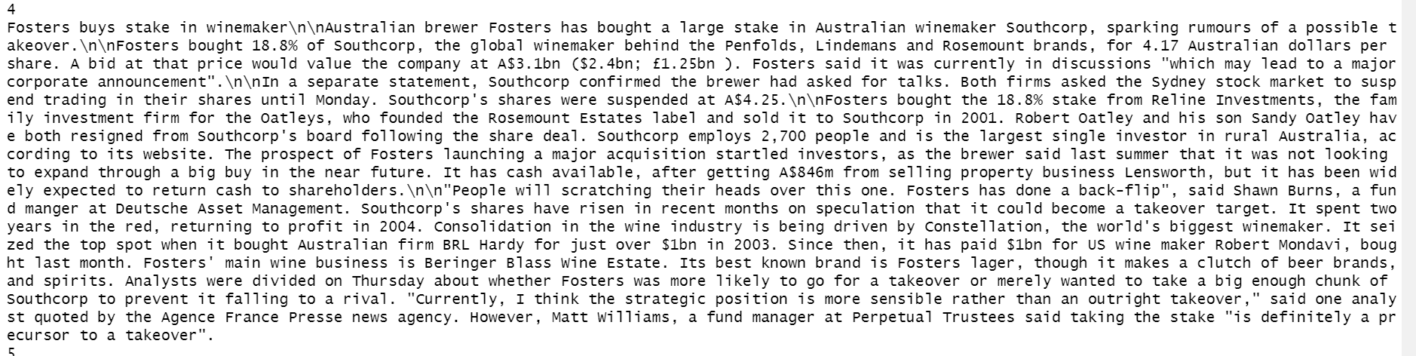 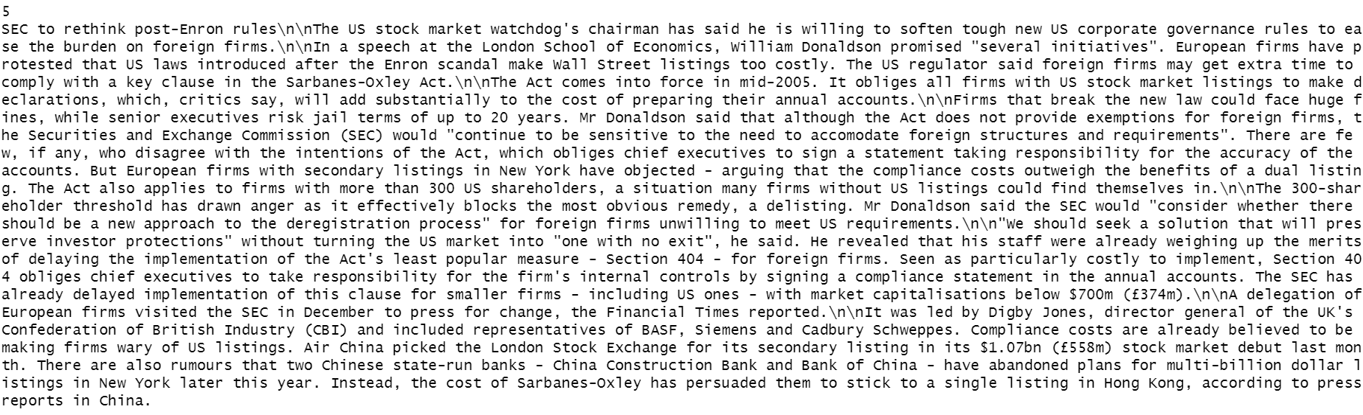*Figure 40: Top 5 text of Corporate Financial Performance*

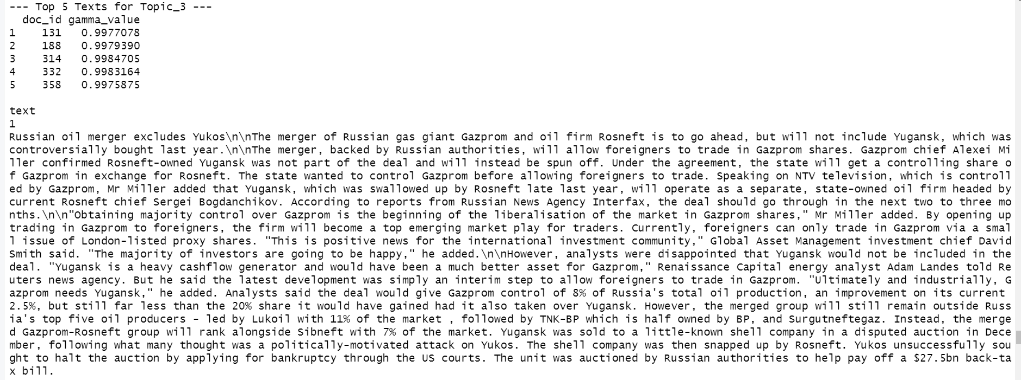 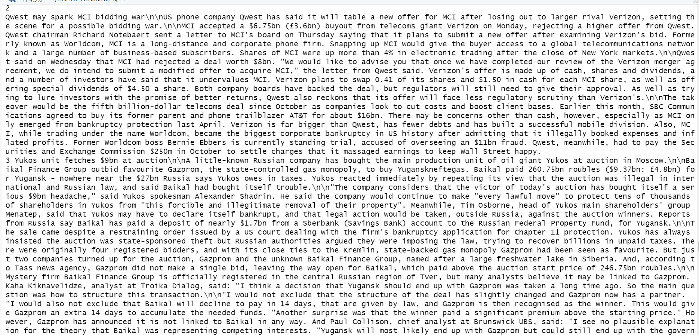 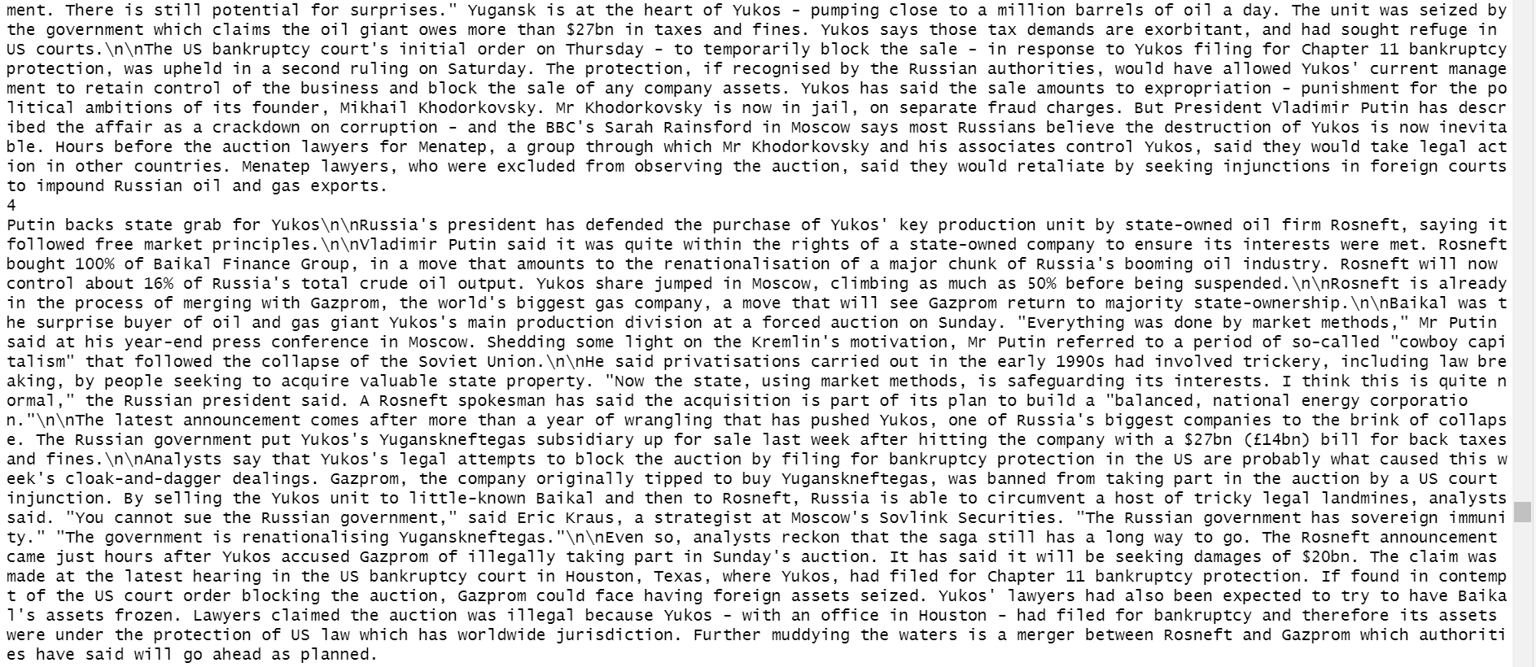 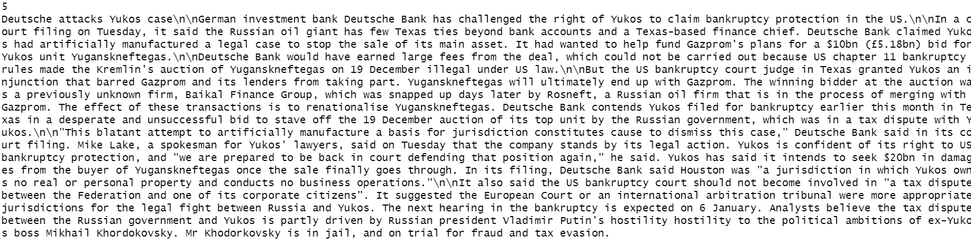

*Figure 41: Top 5 text of Bankruptcies in Russian energy industry*

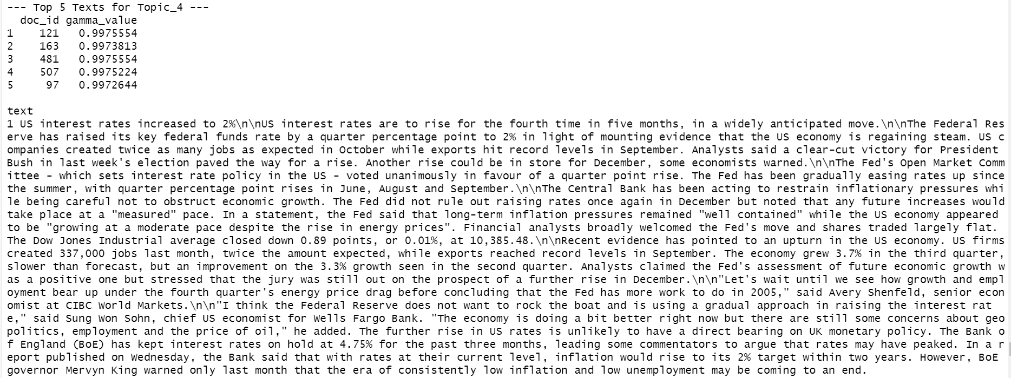 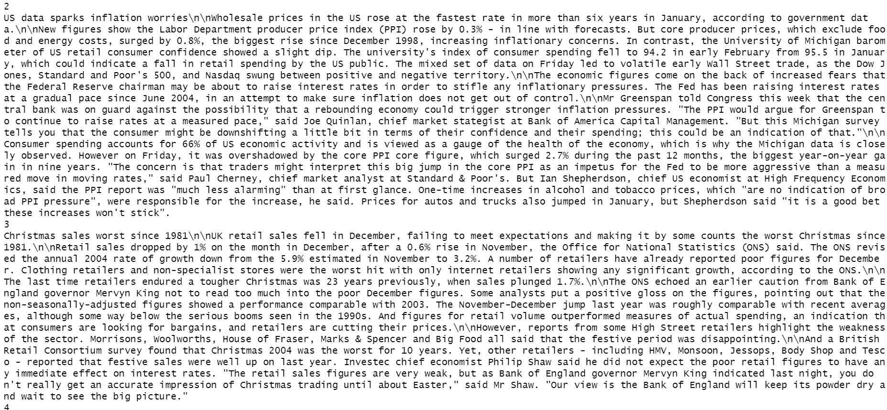 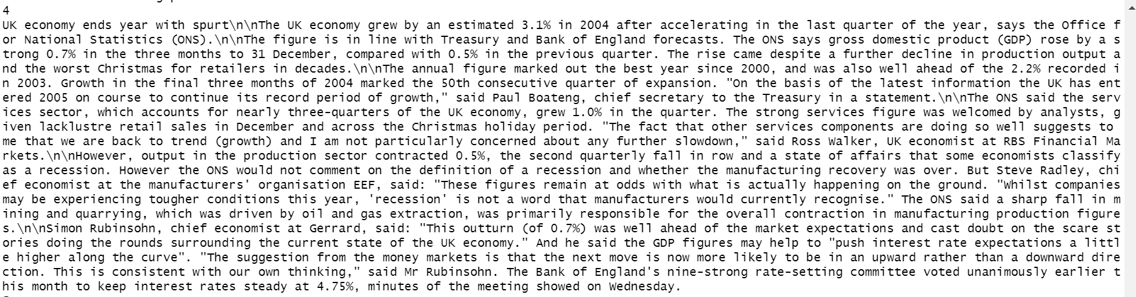 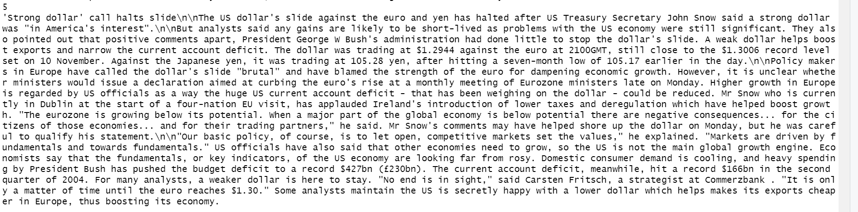

*Figure 42: Top 5 text of Economic growth and interest rates*

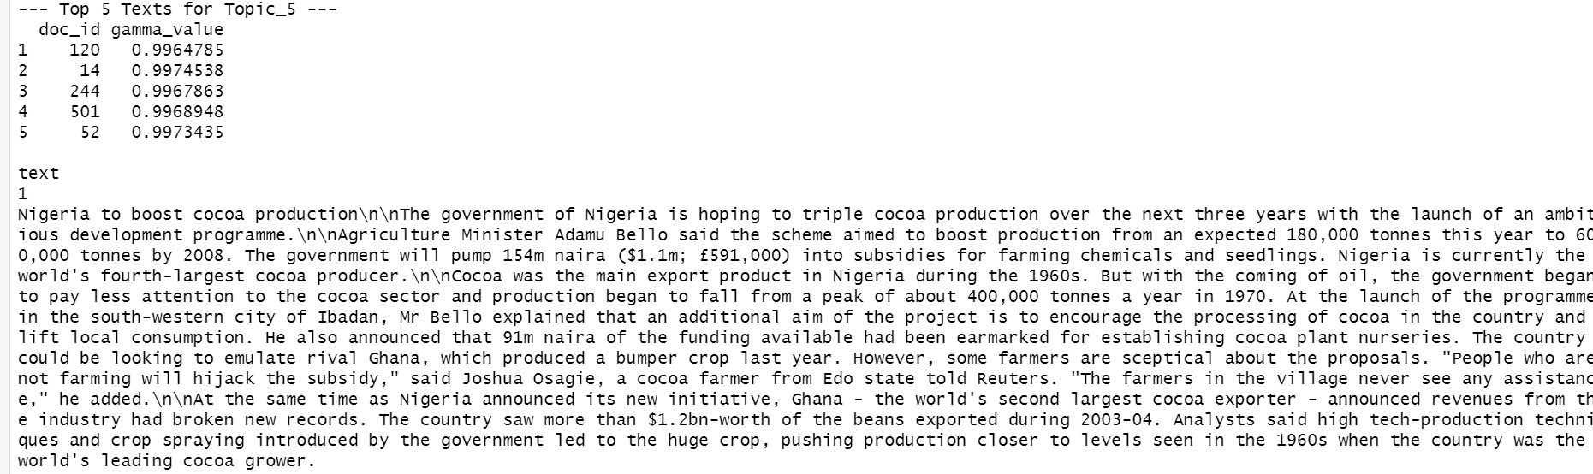 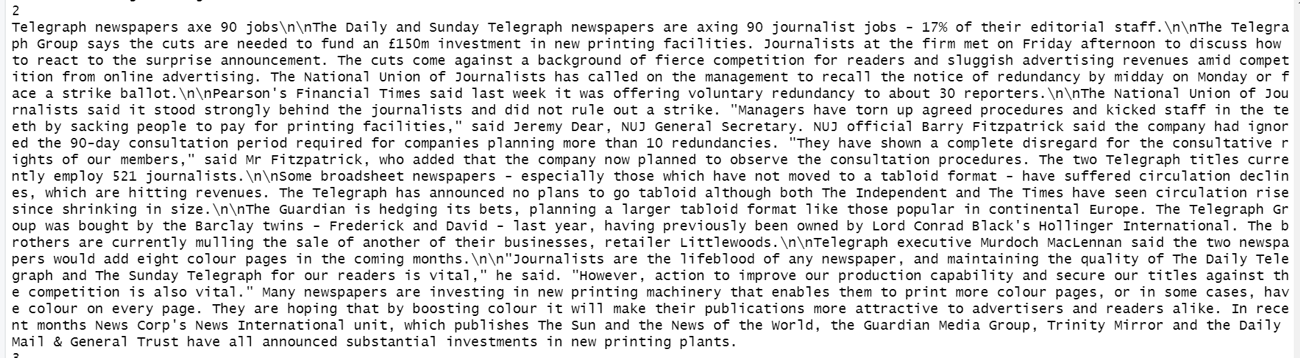 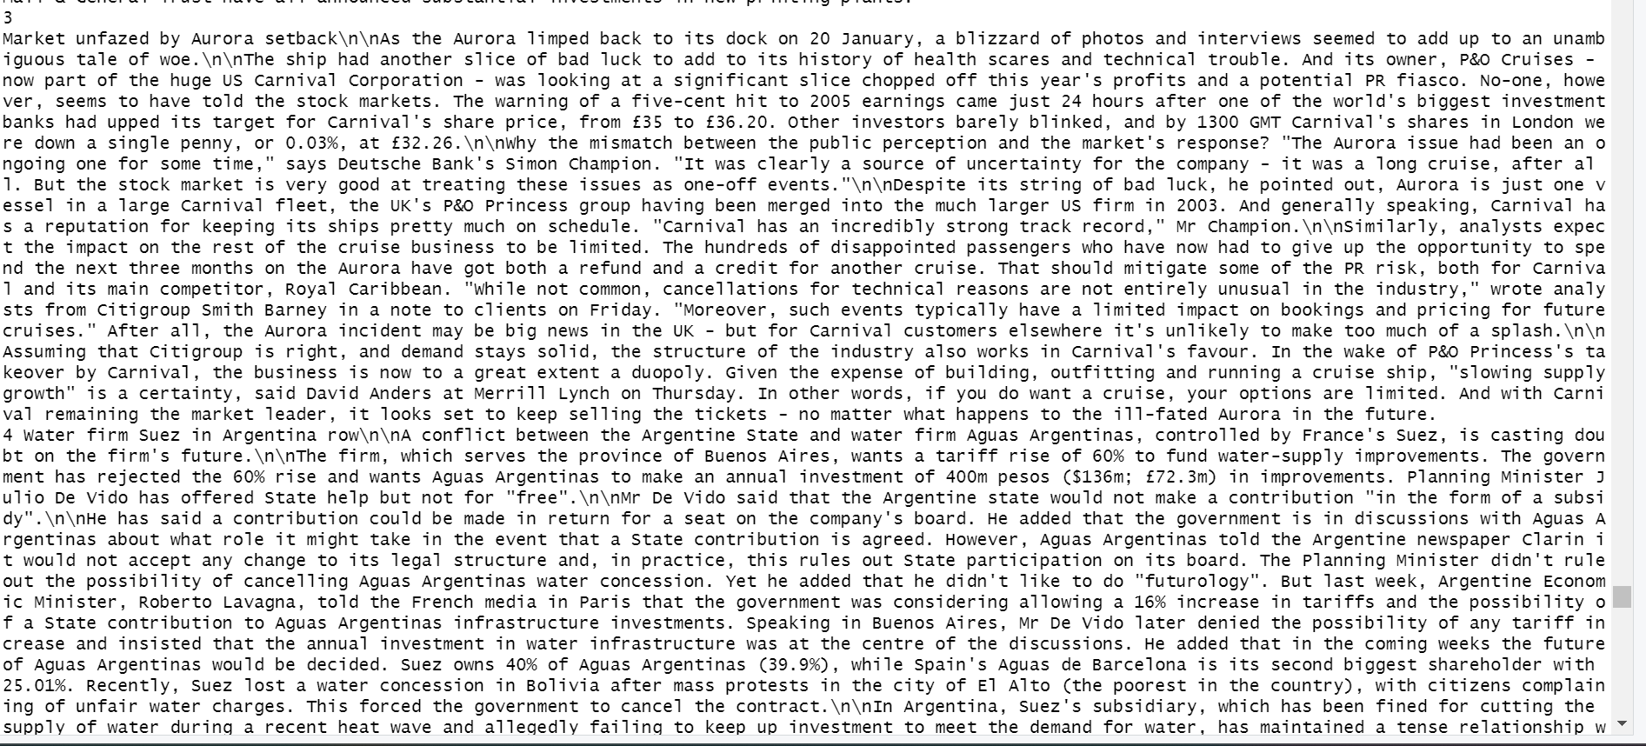

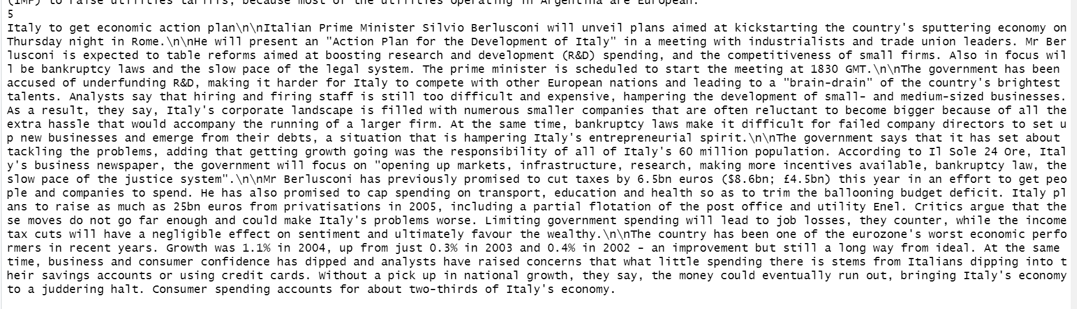

*Figure 43: Top 5 text of Oil and energy markets*

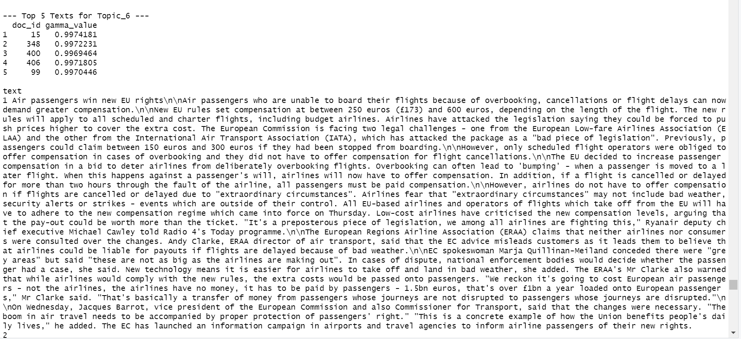

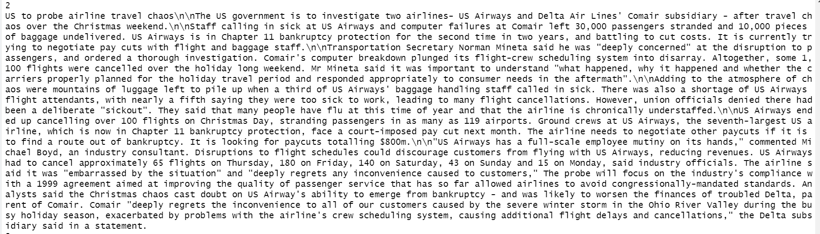 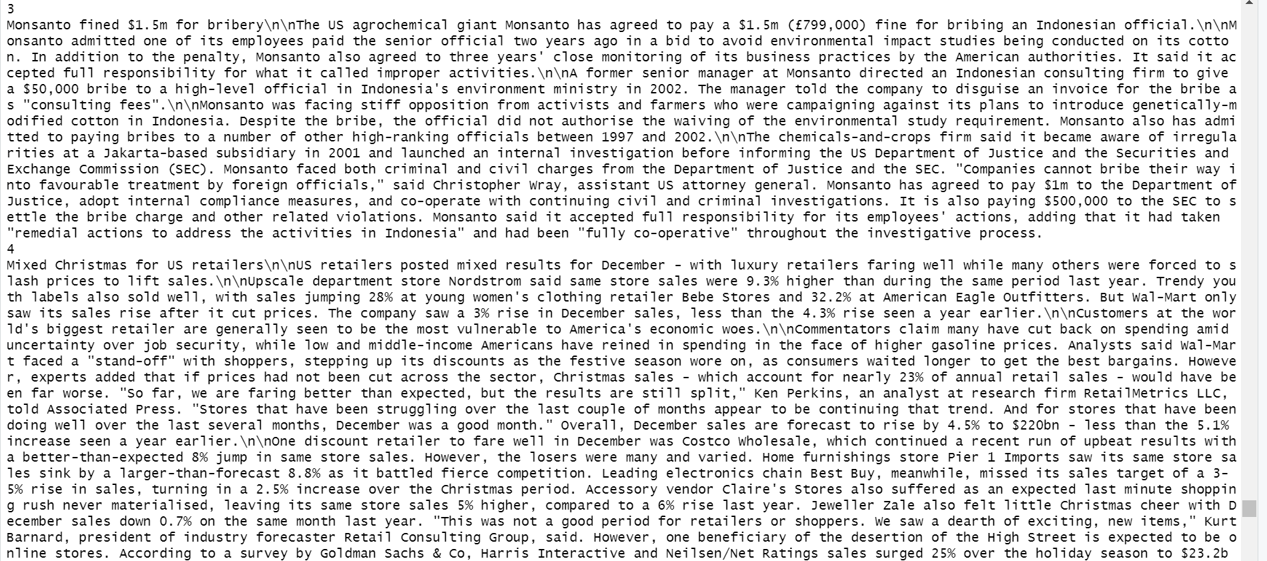

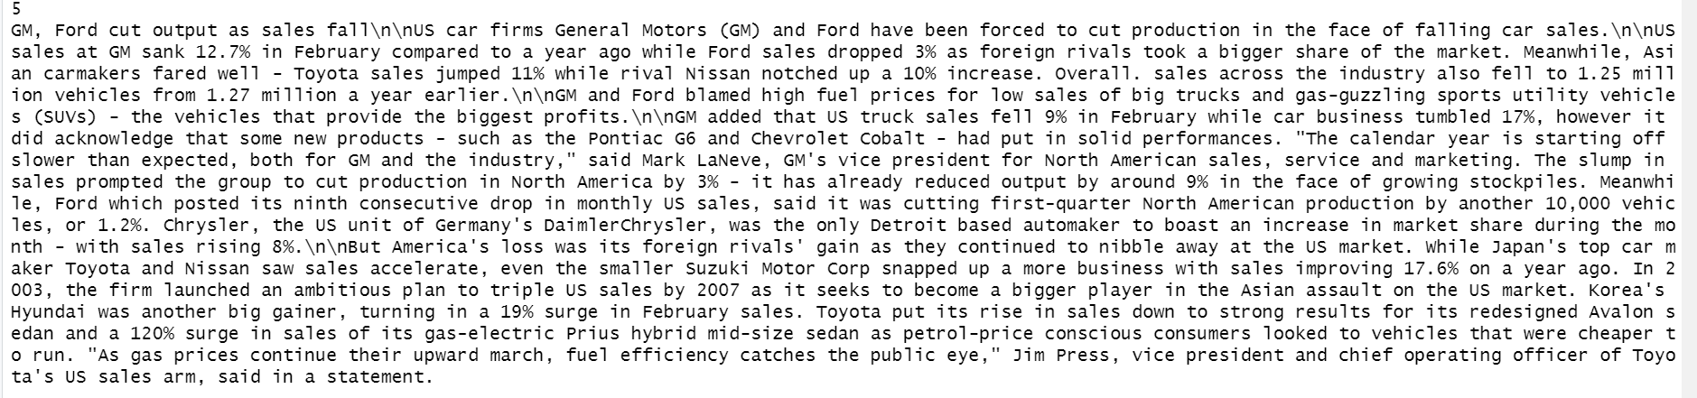

*Figure 44: Top 5 text of Aviation industry*

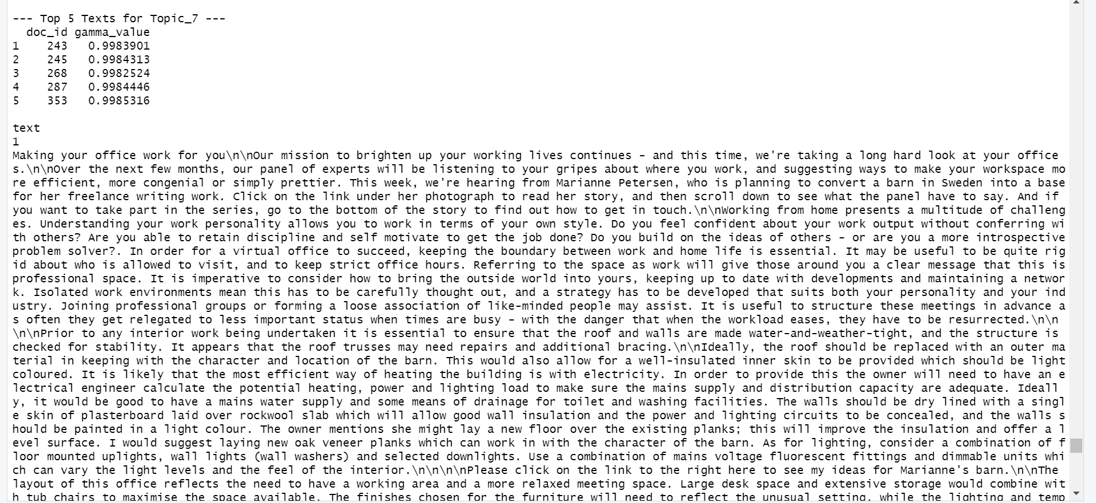 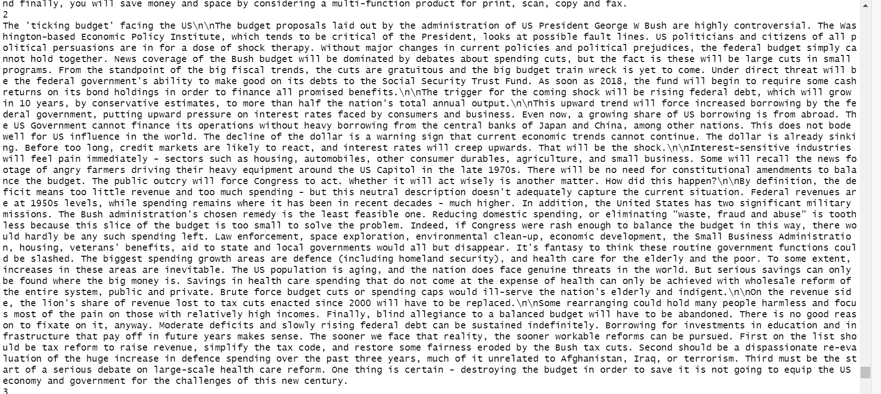 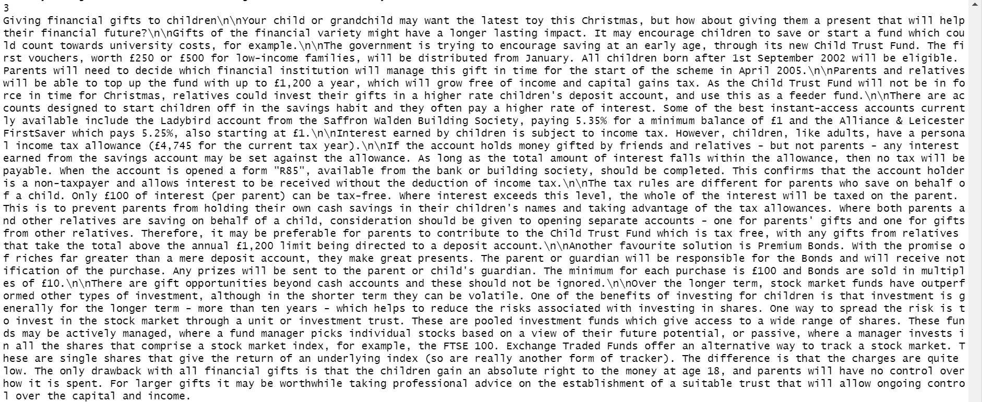 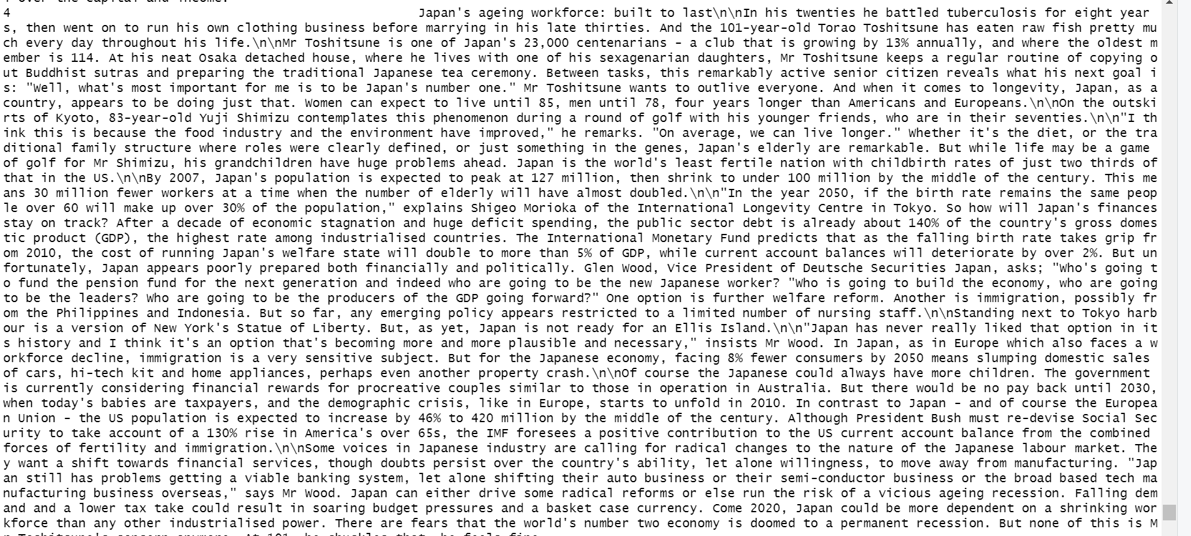 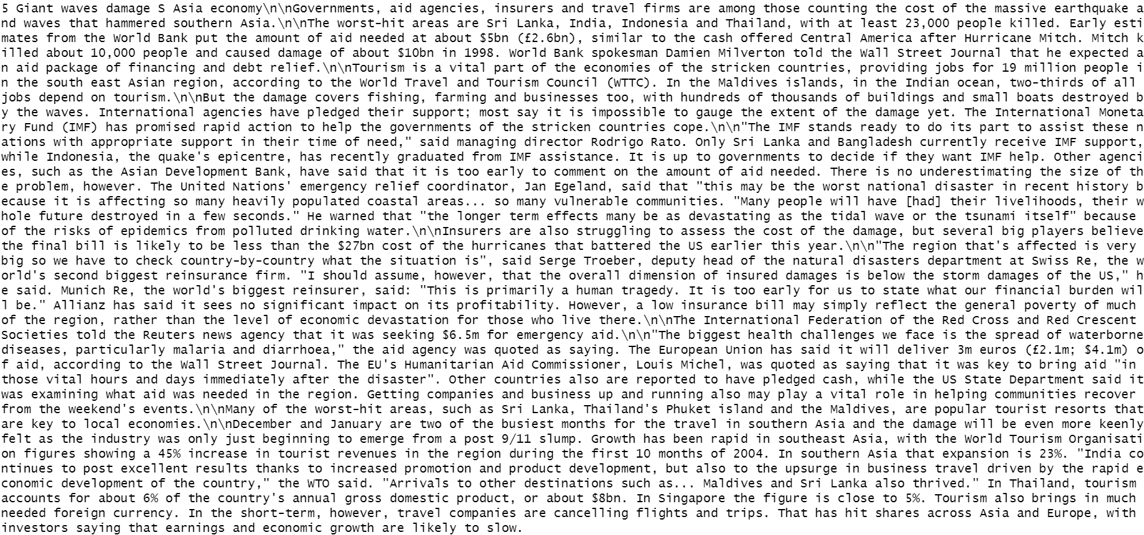

*Figure 45: Top 5 text of Political Influence*

After comparing both methods gamma value, we can evaluate that VEM method is better than Gibbs sampling method.

|  |  |
| --- | --- |
| Topic | VEM |
| Stock exchange and financial markets | club, deal, fiat, boerse, exchange |
| Corporate financial performance | companies, shares, share, profit, companies |
| Bankruptcies in Russian energy industry | yukos, company, bankruptcy, gazprom, mci |
| Economic growth and interest rates | Growth, figures, rate, dollar, interest |
| Oil and energy markets | Crude, growth, president, months, company |
| Aviation industry | Company, airline, deal, companies, shares |
| Political Influence | People, president, work, aid, companies |

To further evaluate the Topic Modelling model, we can consult with a domain experts in finance to study the topics highlighted and research the market trends of 2005 to see the topics that were highlighted were relevant to the market conditions of that time. This would test if the accuracy of the model is good enough to predict and highlight trends of the market. We can continue to work on it until the model reaches an acceptable level of accuracy in highlighting relevant market trends. However, we must ensure that the model is not overfitted to the training data.

** **

*Figure 46: First 30 rows of Sentiment Analysis.*

After examining the Sentiment Analysis, the predicted sentiment still has errors where they are unable predict sentiments accurately. An example is doc_id 4 that model predicted is a positive where the text is talking about how high fuel price were hurting British Airways profit, but they were still able to beat market’s expectations. This is a mixed sentiment document where the market trend is the high price of oil hurting many different industries.

The sentiment analysis model is still not able to fully capture the sentiments of the market. This may be due to the specific vocabulary and terms used in business and finance setting.

We may also want to adopt a supervised sentiment analysis where we conduct document classification methods like decision trees and to train the model on the specific vocabulary and terms used to increase the accuracy of the model in picking out the sentiments of the articles and trends.

3.4 Deployment

For the deployment of the Topic Modelling model, we can pair the model with data from web scraping or integrate Streaming API of social media platforms to the model to ensure that the model has the most updated information and summarise it quickly for the company to keep track of the dynamic market conditions.

However, we will need to periodically update the model on the relevant terms and vocabulary that the market uses such as the rise of Web3.0 has led to new terms like non-fungible tokens (NFTs) and bitcoin. If we do not update the model periodically, its accuracy will suffer and becomes less relevant to the company.

For the Sentiment Analysis model, we can do the same for the dataset of the model like for the Topic Modelling model. We can use HuggingFace to continually improve its accuracy as it is a machine learning platform that will continually learn to make better predictions of the sentiments (Crabtree, 2023).

Chapter 4: Summary

The aim of this project is to conduct text mining on news articles to gain insights into the situation of the market for market understanding. Text mining was to help us identify key market trends through topic modelling and to analyse sentiment of those trends through sentiment analysis

4.1 Key Findings

Through topic modelling, we have seven distinct topics that arise from the analysis. With each topic covering a different area to focus on, we were able to have a holistic outlook of the market. One of the important areas to focus on is the bankruptcy occurring in the Russian energy industry which were the primary supplier of gas to Europe in 2005 (Anderson, 2008). This can have disastrous effects on the European market. This importance is only strengthened by the other topic of oil and energy markets

Another area of focus is aviation industry where in 2005, consumers in the European Union has won more rights while American airlines companies are facing trouble such as US Airways being declared bankrupt again and computer failures causing disruption to passengers.

The topic of the political influence on the market where one of the articles highlight the potential impact of President George W Bush’s budget for America on the market in general. We will need to consider that 2005 was the time where America was still conducting its Global War on Terror as the 9/11 attacks only happened four years ago. The budget was heavily skewed to defence and America’s budget deficit was growing rapidly.

The rest of the topics were covering the general market such as corporate finance performance and the stock market.

4.2 Conclusions

These insights from Topic Modelling can help companies to narrow their focus and effort on these specific areas to better understand the market without being confused by all the noise in the data. Therefore, companies are now able to have a more targeted effort behind attaining market intelligence due to text mining being able to introduce structure to the unstructured external data.

In the future, the models will only get better and more accurate as Artificial Intelligence and natural language processing, which is how computer understand human language, continues to improve and move beyond the English language. This will introduce more options and use case for text mining on market intelligence.

Appendix A

Text Mining Code for ANL312 ECA

install.packages("tm")

install.packages("SnowballC")

install.packages("tidyverse")

install.packages("wordcloud")

install.packages("slam")

install.packages("sentimentr")

install.packages("topicmodels")

library(tm)

library(wordcloud)

library(tidyverse)

library(SnowballC)

library(slam)

txt<- read.csv("C:/users/mikae/Downloads/bbc_text_cls.csv")

business_article <- txt[grepl("business", txt$labels), ]

view(business_article)

business_article$doc_id <- seq.int(nrow(business_article))

names(business_article)[names(business_article) == "text_column_name"] <- "text" # Replace 'text_column_name' with actual text column name

business_articles_corpus <- VCorpus(DataframeSource(business_article[, c("doc_id", "text")]))

# Preprocess the corpus

business_articles <- business_articles_corpus

business_articles <- tm_map(business_articles, content_transformer(tolower))

business_articles <- tm_map(business_articles, removePunctuation)

business_articles <- tm_map(business_articles, removeNumbers)

# Define a custom function to replace unwanted patterns with spaces

toSpace <- content_transformer(function(x, pattern) gsub(pattern, " ", x))

business_articles <- tm_map(business_articles, toSpace, "[^A-Za-z']")

business_articles

mystopwords<- scan(file="C:/Users/mikae/Downloads/mystopwords (2).data", what=character(),sep="\n")

business_articles<-tm_map(business_articles,removeWords,mystopwords[1:689])

business_articles<-tm_map(business_articles, removeWords, c(stopwords("english")))

business_articles<-tm_map(business_articles,stripWhitespace)

# comments<-tm_map(comments,FUN=tm_reduce,tmFuns=list(stemDocument,stripWhitespace)) combine the transformations in one command

dtm<-DocumentTermMatrix(business_articles)

dtm_tfidf<-weightTfIdf(dtm, normalize=TRUE)

dtm$dimnames$Terms

dim(dtm)

inspect(dtm)

summary(dtm_tfidf$v)

dtm_reduced<-dtm[,dtm_tfidf$v>=0.05] # keep all the terms with a tfidf value >=0.05

# Use slam::row_sums to filter documents with at least one term

dtm_reduced <- dtm_reduced[slam::row_sums(dtm_reduced) > 0, ]

inspect(dtm_reduced)

dim(dtm_reduced)

library(topicmodels)

#lda model

k<-7

seed<-2020

model_lda<-list(VEM=LDA(dtm_reduced,k=k,method="VEM",control=list(seed=seed)),

Gibbs=LDA(dtm_reduced,k=k,method="Gibbs",control=list(seed=seed,burnin=1000,thin=100,iter=1000)))

#results

terms_vem<-terms(model_lda$VEM,5)

terms_gibbs<-terms(model_lda$Gibbs,5)

terms_vem

terms_gibbs

#cell values as posterior topic distribution for each document.

#This will show you what documents belong to which topic with the highest probability

gammaDF_vem<-as.data.frame(model_lda$VEM@gamma,row.names=model_lda$VEM@documents)

names(gammaDF_vem)<-c(1:k)

View(gammaDF_vem)

gammaDF_gibbs<-as.data.frame(model_lda$Gibbs@gamma,row.names=model_lda$VEM@documents)

names(gammaDF_gibbs)<-c(1:k)

View(gammaDF_gibbs)

# Extract the gamma matrix from the LDA model (Gibbs method here)

gamma_matrix <- gammaDF_gibbs

colnames(gamma_matrix) <- paste0("Topic_", 1:k) # Rename columns to indicate topics

gamma_matrix$doc_id <- rownames(gamma_matrix) # Add document IDs

# List to store the top 5 documents for each topic

top_docs_by_topic <- list()

# Loop through each topic to find top 5 documents

for (topic in colnames(gamma_matrix)[1:k]) {

top_docs <- gamma_matrix %>%

dplyr::select(doc_id, !!sym(topic)) %>%

dplyr::arrange(desc(!!sym(topic))) %>%

dplyr::slice(1:5) %>%

dplyr::rename(gamma_value = !!sym(topic)) # Rename for clarity

top_docs_by_topic[[topic]] <- top_docs

}

# Retrieve original texts for top documents for each topic

top_texts_by_topic <- lapply(top_docs_by_topic, function(df) {

merge(df, business_article, by.x = "doc_id", by.y = "doc_id") %>%

dplyr::select(doc_id, gamma_value, text) # Keep only necessary columns

})

# Print top texts for each topic

for (topic in names(top_texts_by_topic)) {

cat("\n\n--- Top 5 Texts for", topic, "---\n")

print(top_texts_by_topic[[topic]])

}

# Extract the gamma matrix from the LDA model (VEM method here)

gamma_matrix <- gammaDF_vem

colnames(gamma_matrix) <- paste0("Topic_", 1:k) # Rename columns to indicate topics

gamma_matrix$doc_id <- rownames(gamma_matrix) # Add document IDs

# List to store the top 5 documents for each topic

top_docs_by_topic <- list()

# Loop through each topic to find top 5 documents

for (topic in colnames(gamma_matrix)[1:k]) {

top_docs <- gamma_matrix %>%

dplyr::select(doc_id, !!sym(topic)) %>%

dplyr::arrange(desc(!!sym(topic))) %>%

dplyr::slice(1:5) %>%

dplyr::rename(gamma_value = !!sym(topic)) # Rename for clarity

top_docs_by_topic[[topic]] <- top_docs

}

# Retrieve original texts for top documents for each topic

top_texts_by_topic <- lapply(top_docs_by_topic, function(df) {

merge(df, business_article, by.x = "doc_id", by.y = "doc_id") %>%

dplyr::select(doc_id, gamma_value, text) # Keep only necessary columns

})

# Print top texts for each topic

for (topic in names(top_texts_by_topic)) {

cat("\n\n--- Top 5 Texts for", topic, "---\n")

print(top_texts_by_topic[[topic]])

}

library(sentimentr)

mytext<-get_sentences(business_article)

sentiment_by_sentence<-sentiment(mytext)

sentiment_by_sentence

sentiment_by_article<-sentiment_by(mytext)

article_sentiment<-cbind(business_article, sentiment_by_article)

article_sentiment$pre_sentiment[article_sentiment$ave_sentiment>0]<-1

article_sentiment$pre_sentiment[article_sentiment$ave_sentiment==0]<-0

article_sentiment$pre_sentiment[article_sentiment$ave_sentiment<0]<--1

View(article_sentiment)

write.csv(new, "C:/Users/User/Downloads/article_sentiment.csv", row.names = TRUE)

References

AlphaSense. (n.d.). *The top 5 market intelligence challenges.* <https://www.alpha-sense.com/resources/market-intelligence-challenges/>

Anderson, R. J. (2008, September). *Europe’s Dependence on Russian Natural Gas: Perspectives and Recommendations for a Long-term Strategy.* George C. Marshall European Center For Security Studies. <https://www.marshallcenter.org/en/publications/occasional-papers/europes-dependence-russian-natural-gas-perspectives-and-recommendations-long-term-strategy-0#:~:text=At%2037.7%25%20of%20the%20EU,gas%20supplier%20to%20the%20continent>.

Crabtree, M. (2023, July 19). *What is machine learning? definition, types, tools & more*. DataCamp. <https://www.datacamp.com/blog/what-is-machine-learning>

Crowley, E. (2007, June 11). Market Intelligence: Definition, Types, and Uses. Pragmatic Institute. <https://www.pragmaticinstitute.com/resources/articles/product/a-market-intelligence-primer/>

IBM Cloud Education (2021, June 29). *Structured vs. unstructured data: What’s the difference?* IBM. <https://www.ibm.com/think/topics/structured-vs-unstructured-data>

Kilduff, E. (2020, December 4). <https://www.thoughtspot.com/blog/internal-data-and-external-data-equals-augmented-decision-making>

Kim, Y., & Jeong, S. R. (2018). Competitive intelligence in Korean Ramen Market using Text Mining and Sentiment Analysis. *Journal of Internet Computing and Services* , *19* (1), 155–166. <https://doi.org/10.7472/JKSII.2018.19.1.155>

Liu, B. (2012, April 22). *Sentiment Analysis and Opinion Mining* Morgan & Claypool Publishers. <https://www.cs.uic.edu/~liub/FBS/SentimentAnalysis-and-OpinionMining.pdf>

Malik, N. (2024, March 21). Market Intelligence vs Market Research: What’s the Difference? Cognition Solutions.

<https://cognition-solutions.com/perspective/market-intelligence-vs-market-research/#:~:text=Imagine%20market%20intelligence%20as%20your,data%2C%20and%20social%20media%20trends>.

Miller, K.H. (2015, April). *Securing Text and Data Mining Rights for Researchers in Academic Libraries.* Carolina Digital Repository.<https://cdr.lib.unc.edu/concern/parent/r494vp858/file_sets/1r66j4822>

Webster, W. (n.d.) Understanding market intelligence tools and how you should use them. Qualtrics.<https://www.qualtrics.com/en-au/experience-management/research/market-intelligence/>

Saltz, J. (2024, April 10). *CRISP-DM is still the most popular framework for executing data science projects*. Data Science Process Alliance.

<https://www.datascience-pm.com/crisp-dm-still-most-popular/#:~:text=CRISP%2DDM%3A%20The%20CRoss,the%20data%20science%20life%20cycle>.

Shacklett, M. (2023, November 14). *Structured vs unstructured data: Key differences*. Datamation. <https://www.datamation.com/big-data/structured-vs-unstructured-data/#:~:text=Examples%20of%20unstructured%20data%20include,handle%20and%20extract%20insights%20from>.

Shi, Z. (Michael), Lee, G. M., & Whinston, A. B. (2016). Toward a Better Measure of Business Proximity: Topic Modeling for Industry Intelligence. *MIS Quarterly*, *40*(4), 1035–1056. <https://www.jstor.org/stable/26629687>